Table of Contents – Exam Review Packet

Period Table, Equation Sheets – 2009 (MC only gets Periodic Table) 3

Equilibrium
Concept List 7
Free Response Questions 9
Multiple Choice Questions 11

Acid / Base
Concept List 14
Free Response Questions 20
Multiple Choice Questions 24

Kinetics
Concept List 27
Free Response Questions 28
Multiple Choice Questions 31

Electrochemistry
Concept List 34
Free Response Questions 35
Multiple Choice Questions 41

Thermodynamics
Concept List 43
Free Response Questions 44
Multiple Choice Questions 48

Atomic Theory, Bonding, and Intermolecular Forces
Concept List 50
Free Response Questions 51
Multiple Choice Questions 57

Concentration and Colligative Properties
Concept List 59
Free Response Questions 60
Multiple Choice Questions 61

Laboratory
Concept Vocabulary 63
Free Response Questions 63
Multiple Choice Questions 70

Nuclear
Free Response Questions 73
Multiple Choice Questions 73

Multiple Concept
Free Response Questions 76
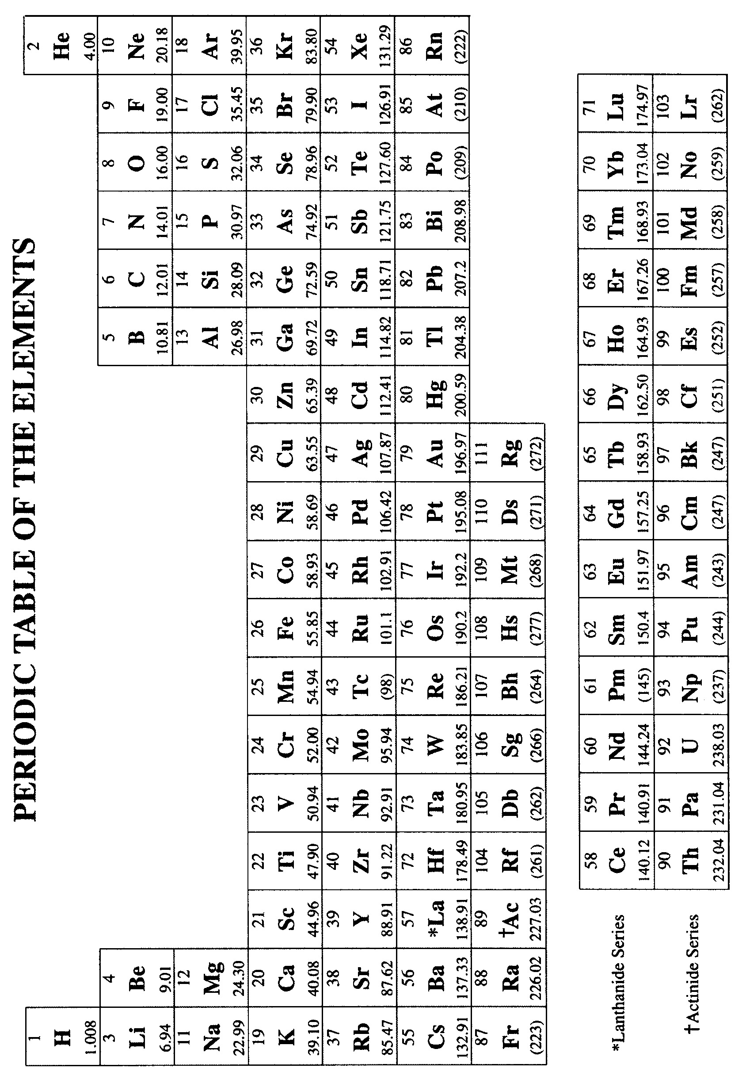
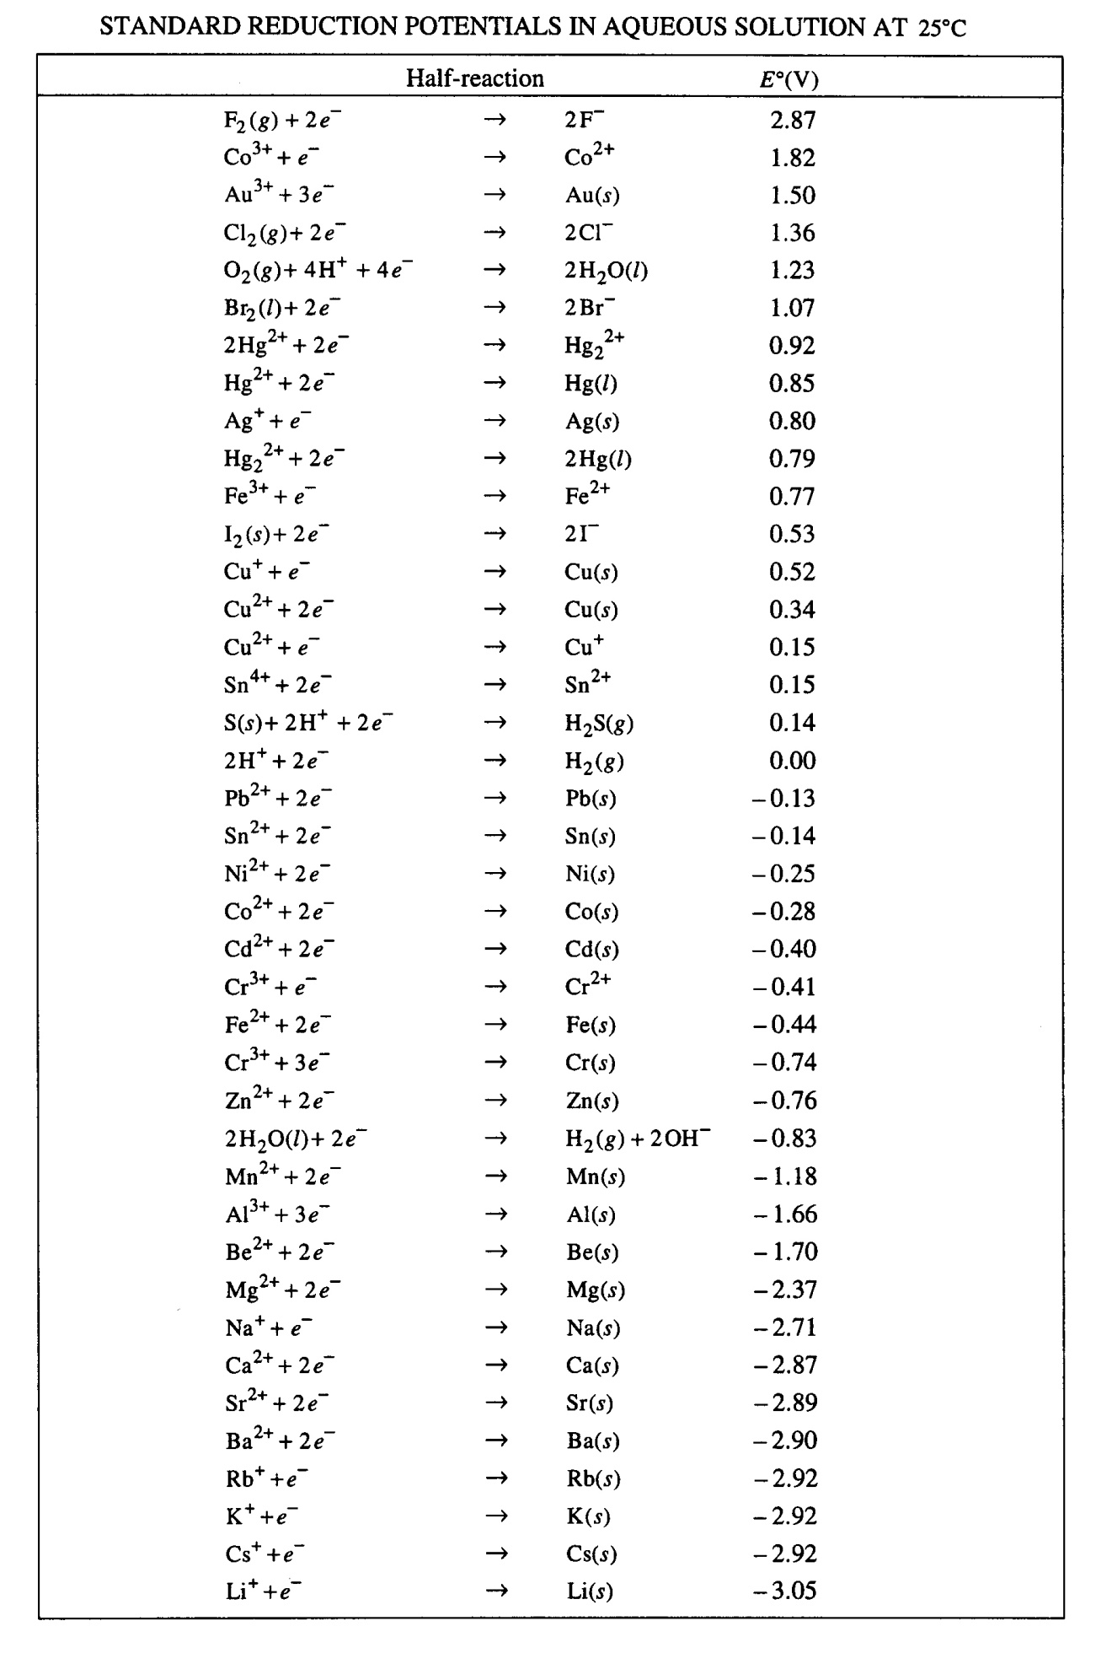
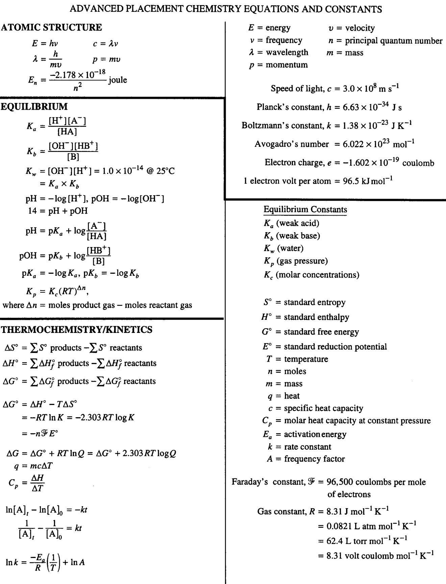
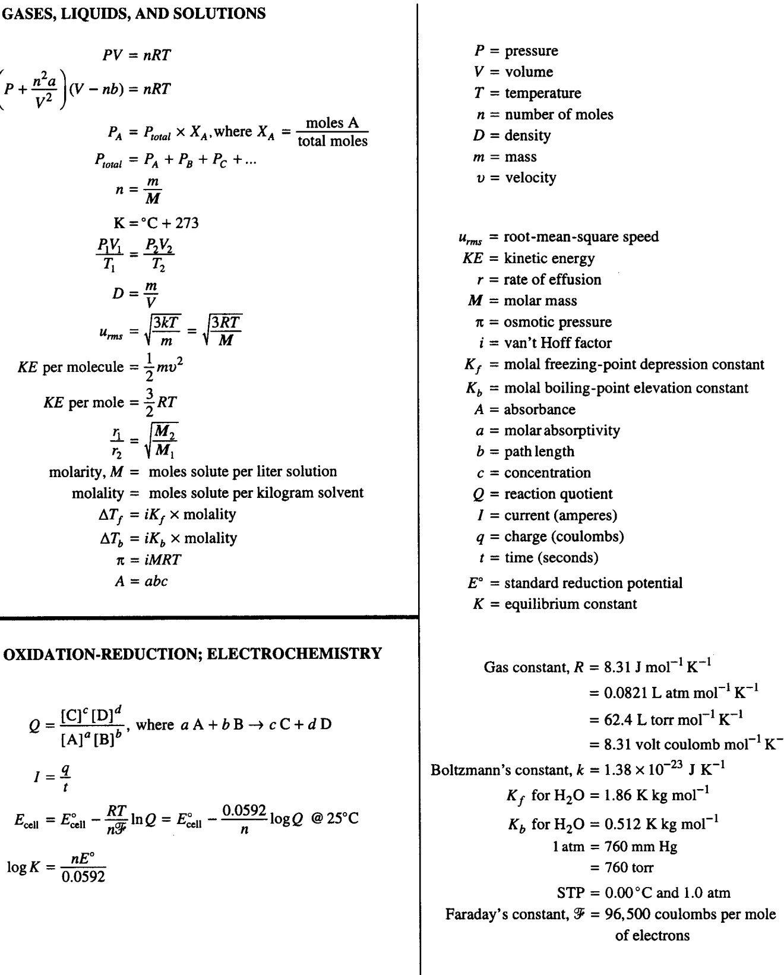
AP Chemistry Concept List – EQUILIBRIUM

All Problems are equilibrium problems because

All problems involve stoichiometry: soluble salts, strong acids, strong bases
Some problems involve equilibrium: “insoluble” salts, weak acids, weak bases

For chemical reactions – K_{eq}, K_{c}, and K_{p} are the important quantities

For physical changes – K_{a}, K_{b}, K_{sp}, K_{ionize}, and K_{dissocation} are the important quantities

Important points

1. Law of mass action
aA + bB + … rR +sS + xxx

K_{c} = [R]^{r} [S]^{s} … / [A]ª [B]^{b} …

2. K_{c} for molarity for ions and gases

3. K_{p} with atm, or mmHg for gases
Relationship / connection between these K_{p} = K_{c} (RT)^{Δn}

4. Orientation of collisions

5. Shifting equilibrium – Le Chatlier’s Principle
a. solid
b. liquid
c. catalyst
d. inert gas added
e. temperature changes (increasing T favors endothermic processes)
f. only factors in equation constant will affect K_{eq} eg. CaCO₃(s) CaO(s) + CO₂(g)
g. pressure / volume changes

6. Important vocabulary

Driving force
Favors (reactants or products)
Shifts (in LeChatelier arguments)

7. K > 1 products favored

K < 1 reactants favored

8. Excluded: solids, pure liquids, water (in aqueous solution)

9. Typical question: Given K_{c} and the starting concentration of reactants, find the concentration (or pH !) of products at equilibrium.

Example: K_{c} of acetic acid = 1.754 × 10⁻⁵. Find the pH of a 0.100 M solution of acetic acid.

10. Equilibrium constant for a reverse reaction = 1 / K of the value of the forward reaction.

11. When using Hess’s Law: K_{overall} = K₁ × K₂

12. If out of equilibrium: Calculate the reaction quotient (Q) in a similar fashion to the way an equilibrium constant would be found. If:

Q < K forward reaction occurs to reach equilibrium

Q > K reverse reaction occurs to reach equilibrium

13. Problem solving: Learn when to make an approximation (needed for multiple choice and free response questions!). 5% rules usually works when value of K is 10⁻² or smaller than value of known concentrations.

Example: A B + C K = 3.0 × 10⁻⁶

If [A] = 5.0 M; find [C] at equilibrium

If greater than 5 % use the quadratic equation:

ax² + bx + c = 0

Free Response Questions

2003B #1

After a 1.0 mole sample of HI(g) is placed into an evacuated 1.0 L container at 700. K, the reaction represented occurs. The concentration of HI(g) as a function of time is shown below.

2 HI(g) H₂(g) + I₂(g)

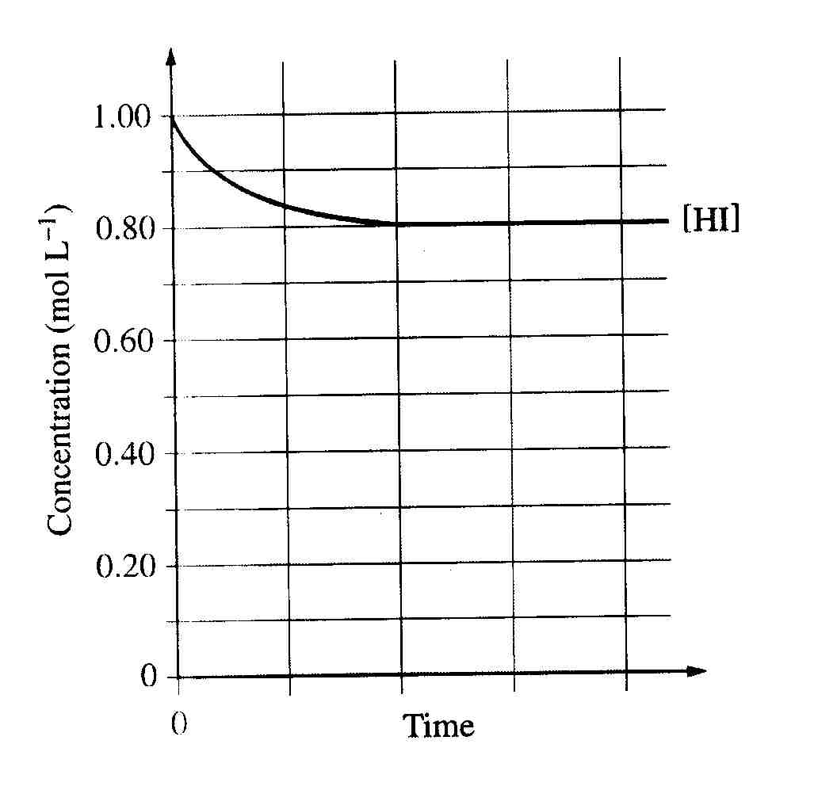

a. Write the expression for the equilibrium constant, K_{c}, for the reaction.

b. What is [HI] at equilibrium?

c. Determine the equilibrium concentrations of H₂(g) and I₂(g).

d. On the graph above, make a sketch that shows how the concentration of H₂(g) changes as a function of time.

e. Calculate the value of the following equilibrium constants at 700. K.

i. K_{c}

ii. K_{p}

f. At 1,000 K, the value of K_{c} for the reaction is 2.6 × 10⁻². In an experiment, 0.75 mole of HI(g), 0.10 mole of H₂(g), and 0.50 mole of I₂(g) are placed in a 1.0 L container and allowed to reach equilibrium at 1,000 K. Determine whether the equilibrium concentration of HI(g) will be greater than, equal to, or less than the initial concentration of HI(g). Justify your answer.

2004B #1

N₂(g) + 3 H₂(g) 2 NH₃(g)

For the reaction represented above, the value of the equilibrium constant, K_{p} is 3.1 × 10⁻⁴ at 700 K.

a. Write the expression for the equilibrium constant, K_{p}, for the reaction.

b. Assume that the initial partial pressures of the gases are as follows:

P(N₂) = 0.411 atm, P(H₂) = 0.903 atm, and P(NH₃) = 0.224 atm.

i) Calculate the value of the reaction quotient, Q, at these initial conditions.

ii) Predict the direction in which the reaction will proceed at 700. K if the initial partial pressures are those given above. Justify your answer.

c. Calculate the value of the equilibrium constant, K_{c}, given that the value of K_{p} for the reaction at 700. K is 3.1 × 10⁻⁴.

d. The value of K_{p} for the reaction represented below is 8.3 × 10⁻³ at 700. K.

NH₃(g) + H₂S(g) NH₄HS(g)

Calculate the value of K_{p} at 700. K for each of the reactions represented below.

i) NH₄HS(g) NH₃(g) + H₂S(g)

ii) 2 H₂S(g) + N₂(g) + 3 H₂(g) 2 NH₄HS(g)

1988 #6 NH₄HS(s) NH₃(g) + H₂S(g)

For this reaction, ΔH° = + 93 kilojoules. The equilibrium above is established by placing solid NH₄HS in an evacuated container at 25 °C. At equilibrium, some solid NH₄HS remains in the container. Predict and explain each of the following.

a. The effect on the equilibrium partial pressure of NH₃ gas when additional solid NH₄HS is introduced into the container.

b. The effect on the equilibrium partial pressure of NH₃ gas when additional H₂S gas is introduced into the container.

c. The effect on the mass of solid NH₄HS present when the volume of the container is decreased.

d. The effect on the mass of solid NH₄HS present when the temperature is increased

1980 #6

NH₄Cl(s) NH₃(g) + HCl(g) for this reaction, ΔH = +42.1 kilocalories

Suppose the substances in the reaction above are at equilibrium at 600 K in volume V and at pressure P. State whether the partial pressure of NH₃(g) will have increased, decreased, or remained the same when equilibrium is reestablished after each of the following disturbances of the original system. Some solid NH₄Cl remains in the flask at all times. Justify each answer with a one- or two-sentence explanation.
a. A small quantity of NH₄Cl is added.
b. The temperature of the system is increased.
c. The volume of the system is increased.
d. A quantity of gaseous HCl is added.
e. A quantity of gaseous NH₃ is added.
Multiple Choice Questions

1999 #67 What is the molar solubility in water of Ag₂CrO₄? (The K_{sp} for Ag₂CrO₄ is 8 × 10⁻¹².)
A) 8 × 10⁻¹² M
B) 2 × 10⁻¹² M
C) (4 × 10⁻¹² M)^{1/2}
D) (4 × 10⁻¹² M)^{1/3}
E) (2 × 10⁻¹² M)^{1/3}

2008 #59 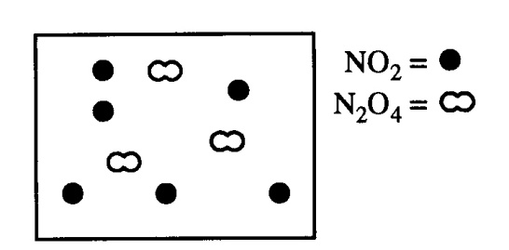
The diagram above represents a mixture of NO₂(g) and N₂O₄(g) in a 1.0 L container at a given temperature. The two gases are in equilibrium according to the equation 2 NO₂(g) N₂O₄(g). Which of the following must be true about the value of the equilibrium constant for the reaction at this temperature?

A) K = 0
B) 0 < K < 1
C) K = 1
D) K > 1
E) There is not enough information to determine the relative value of K.

2002 #42 H₂(g) + Br₂(g) 2 HBr(g)

At a certain temperature, the value of the equilibrium constant, K, for the reaction represented above is 2.0 × 10⁵. What is the value of K for the reverse reaction at the same temperature?

A) -2.0 × 10⁻⁵
B) 5.0 × 10⁻⁶
C) 2.0 × 10⁻⁵
D) 5.0 × 10⁻⁵
E) 5.0 × 10⁻⁴

2008 #35 H₂(g) + I₂(g) 2 HI(g) ΔH > 0

Which of the following changes to the equilibrium system represented above will increase the quantity of HI(g) in the equilibrium mixture?
I. Adding H₂(g)
II. Increasing the temperature
III. Decreasing the pressure

A) I only
B) III only
C) I and II only
D) II and III only
E) I, II, and III

1999 #54 2NO(g) + O₂(g) 2 NO₂(g) ΔH < 0
Which of the following changes alone would cause a decrease in the value of K_{eq} for the reaction represented above?
A) Decreasing the temperature
B) Increasing the temperature
C) Decreasing the volume of the reaction vessel
D) Increasing the volume of the reaction vessel
E) Adding a catalyst

2002 #37 HCO₃⁻(aq) + OH⁻(aq) H₂O(l) + CO₃²⁻(aq) ΔH = -41.4 kJ

When the reaction represented by the equation above is at equilibrium at 1 atm and 25 ºC, the ratio can be increased by doing which of the following?

A) Decreasing the temperature
B) Adding acid
C) Adding a catalyst
D) Diluting the solution with distilled water
E) Bubbling neon gas through the solution

AP Chemistry Concept List – ACID - BASE

pH = - log [H⁺] pOH = - log [OH⁻] K_{w} = [H⁺] [OH⁻] = 1×10⁻¹⁴ at 25 ºC

If you know one quantity, you know the other three

Definitions

Acid | Base | Theory
Donates H⁺ | Donates OH⁻ | Arrhenius
Donates protons | Accepts protons - {anions?} | Bronsted – Lowry
Accepts e⁻ pairs (AlCl₃) | Donates e⁻ pairs (NH₃) | Lewis

Conjugate Acid – Base Pairs

1. HCl + H₂O → H₃O⁺ + Cl⁻

2. NH₃ + H₂O NH₄⁺ + OH⁻

3. HSO₄⁻ + H₂O H₃O⁺ + SO₄²⁻

4. CO₃²⁻ + H₃O⁺ HCO₃⁻ + H₂O

A. K_{a} Weak Acid HCN H⁺ + CN⁻

What is the pH of a 0.5 M HCN solution?

B. K_{b} Weak base NH₃ + H₂O NH₄⁺ + OH⁻

What is the pH of a 0.5 M NH₂OH solution?

C. K_{sp} Insoluble Salts MgF₂(s) Mg²⁺ + 2F⁻

K_{sp} = [Mg²⁺] [F⁻]² = 6.6 × 10⁻⁹

What is the solubility of MgF₂ in molarity?

D. Buffers – a weak acid/base and its soluble salt (conjugate base or acid) mixture

What is the pH of a 0.5 M HC₂H₃O₂ in 2 M NaC₂H₃O₂ solution? K_{a} = 1.8 × 10⁻⁵

E. Salts of Weak Acids and Weak Bases

What is the pH of a 1 M NaC₂H₃O₂ solution?

Titrations and Endpoints

At endpoint: acid moles = base moles or [H⁺] = [OH⁻]

Strong acid – strong base endpoint pH = 7

Strong acid – weak base endpoint pH < 7

Weak acid – strong base endpoint pH > 7

The last two are important because of conjugate acid and base pairs

11. Acid strength – know the 6 strong acids: HCl, HBr, HI, HNO₃, HClO₄, and H₂SO₄ (removal of the first H⁺ only)

a) binary acids – acid strength increased with increasing size and electronegativity of the “other element”. (NOTE: Size predominates over electronegativity in determining acid strength.)

Example: H₂Te > H₂O and HF > NH₃

b) oxoacids – Acid strength increases with increasing:

1) electronegativity
2) number of bonded oxygen atoms
3) oxidation state

of the “central atom”. However, need to show as electron withdrawing groups rather than trends (trends need to be explained as a result of chemical principles rather than solely as a trend).

Example: HClO₄ [O₃Cl(OH)] is very acidic
NaOH is very basic
Acid strength also increases with DECREASING radii of the “central atom”
Example: HOCl (bond between Cl and OH is covalent – acidic)
HOI (bond between I and OH is ionic – basic)

12. Acid Ionization Constant (K_{a}):

HA + H₂O H₃O⁺ + A⁻

Example: HF + H₂O H₃O⁺ + F⁻

What is the pH of 0.5 M HCN solution for which K_{a} = 6.2 × 10⁻¹⁰?

13. Base Ionization Constant (K_{b}):

B + H₂O BH⁺ + OH⁻

Example: F⁻ + H₂O HF + OH⁻

What is the pH of a 0.5 M NH₂OH solution for which K_{b} = 6.6 × 10⁻⁹?

Do equal number of K_{a} and K_{b} problems as they are equally likely!

14. K_{a} × K_{b} = K_{w} = 10⁻¹⁴

ONLY applies for conjugate acids and bases at 25 ºC!

15. Percent ionization = [H⁺]_{equilibrium} / [HA]_{initial} × 100

16. Lewis Acids and Bases:

Lewis acid – electron pair acceptor
Lewis bases – electron pair donor

In complex ions formation, metal ions are Lewis acids, and ligands are Lewis bases.

Example: Cu²⁺ + 4 NH₃ [Cu(NH₃)₄]²⁺
Cu²⁺ acts as an acid; NH₃ acts as a base

17. Buffers:

Similar concentrations of a weak acid and its conjugate base
-or-
Similar concentrations of a weak base and its conjugate acid

If these concentrations are large in comparison to SMALL amounts of added acid or base, equilibrium will be shifted slightly and the pH change resisted. Consider:

HA H⁺ + A⁻

[H⁺] = K_{a} [HA] / [A⁻]

pH = pK_{a} – log [HA] / [A⁻] or pH = pK_{a} + log [A⁻] / [HA]
(Henderson-Hasselbach equation)

B + H₂O HB⁺ + OH⁻

[OH⁻] = K_{b} [B] / [HB⁺] or pOH = pK_{b} + log [HB⁺]/[B]
(Henderson-Hasselbach equation)

What is the pH of a solution which is 0.5 M HC₂H₃O₂ in 2 M NaC₂H₃O₂ for which K_{a} = 1.8 × 10⁻⁵?

18. Polyprotic Acids: H₃PO₄, H₂SO₄, H₂C₂O₄, etc.

19. Equivalence Point – the point at which stoichiometric amounts of reactants have reacted.

NOTE: This only occurs at pH = 7 for the reaction of a strong acid with a strong base. The equivalence point will occur ABOVE pH = 7 (more basic) for a weak acid / strong base titration. (the conjugate base of the weak acid will react with water.) The equivalence point will occur BELOW pH = 7 for a weak base / strong acid titration (the conjugate acid of the weak base with react with water).

20. Indicators – select bases on the pH at the equivalence point.

21. Titration curves:

a) Weak acid / strong base HA + OH⁻ A⁻ + H₂O

NOTE: Graph should have “pH” as the vertical axis and “added base” as the horizontal axis. The graph should be in an “S” shape. The middle of the lower part of the “S” indicates the point of maximum buffering where [HA] / [A⁻] = 1. The middle of the “S” is the equivalence point (above pH = 7) and [HA] = 0. The top part of the “S” levels off at the pH of the base solution.

b) Weak base / strong acid B + H₃O⁺ BH⁺ + H₂O

NOTE: Graph should have “pH” as the vertical axis and “added base” as the horizontal axis. The graph should be in a “backwards S” shape. The middle of the upper part of the “backwards S” indicates the point of maximum buffering where [B] / [HB⁺] = 1. The middle of the “backwards S” is the equivalence point (below pH = 7) and [B] = 0. The bottom part of the “backwards S” levels off at the pH of the acid solution.

c) Weak diprotic acid / strong base H₂A + OH⁻ HA⁻ + H₂O

HA⁻ + OH⁻ A²⁻ + H₂O

NOTE: Graph should have “pH” as the vertical axis and “added base” as the horizontal axis. The graph should be in a “double S” shape. The middle of the lower part of the “first S” indicates the point of maximum buffering of the first buffering zone where [H₂A] / [HA⁻] = 1. The middle of the “first S” is the first equivalence point where [H₂A] = 0. The top of the “first S” (i.e. the lower part of the “second S”) indicates the point of maximum buffering of the second buffering zone where [HA⁻] / [A²⁻] = 1. The middle of the “second S” is the second equivalence point where [HA⁻] = 0. The top part of the “second S” levels off at the pH of the base solution.

22. Solubility Product (K_{sp})

Example 1: Co(OH)₂(s) Co²⁺ + 2OH⁻ K_{sp} = [Co²⁺][OH⁻]²
(don’t forget – molar concentration of OH⁻ is twice the solubility)

Example 2: Solubility of Ag₂SO₄ is 0.016 mol L⁻¹ (5.0 g L⁻¹). Find the K_{sp} of Ag₂SO₄. (Answer: K_{sp} = 1.5 × 10⁻⁵)

23. Ion product (Q_{i}) – equivalent to the “reaction quotient”

Q_{i} < K_{sp} all ions in solution; more solid will dissolve
Q_{i} = K_{sp} equilibrium – solution is saturated
Q_{i} > K_{sp} precipitation will occur until Q_{i} = K_{sp}

24. Solubility of any salt which contains a basic anion is influenced by pH:

Example: Consider a solution which is 1 M in each of Fe³⁺ and H⁺. Will Fe(OH)₃ precipitate? Answer: NO!

Fe(OH)₃ Fe³⁺ + 3 OH⁻

Q_{i} = [Fe³⁺][OH⁻]

If [H⁺] = 1 M, then [OH⁻] = 10⁻¹⁴

Q_{i} = (1) (10⁻¹⁴)³ = 10⁻⁴²

Since K_{sp} for Fe(OH)₃ = 3 × 10⁻³⁹; precipitation does not occur.

However, what if [H⁺] = 10⁻⁵? Then [OH⁻] = 10⁻⁹
Q_{i} = (1) (10⁻⁹)³ = 10⁻²⁷
Since Q_{i} > K_{sp}; Fe(OH)₃ will precipitate!

Free Response Questions

2007 #1

1. HF(aq) + H₂O(l) H₃O⁺(aq) + F⁻(aq) K_{a} = 7.2 × 10⁻⁴

Hydrofluoric acid, HF(aq), dissociates in water as represented by the equation above.

a. Write the equilibrium constant expression for the dissociation of HF(aq) in water.

b. Calculate the molar concentration of H₃O⁺ in a 0.40 M HF(aq) solution.

HF(aq) reacts with NaOH(aq) according to the reaction represented below.

HF(aq) + OH⁻(aq) H₂O(l) + F⁻(aq)

A volume of 15 mL of 0.40 M NaOH(aq) is added to 25 mL of 0.40 M HF(aq) solution. Assume volumes are additive.

c. Calculate the number of moles of HF(aq) remaining in the solution.

d. Calculate the molar concentration of F⁻(aq) in the solution.

e. Calculate the pH of the solution.

2005B #1 K_{a}

1. Hypochlorous acid, HOCl, is a weak acid in water. The K_{a} expression for HOCl is shown above.

a. Write a chemical equation showing how HOCl behaves as an acid in water.

b. Calculate the pH of a 0.175 M solution of HOCl.

c. Write the net ionic equation for the reaction between the weak acid HOCl(aq) and the strong base NaOH(aq)

d. In an experiment, 20.00 mL of 0.175 M HOCl(aq) is placed in a flask and titrated with 6.55 mL of 0.435 M NaOH(aq).

i) Calculate the number of moles of NaOH(aq) added.

ii) Calculate [H₃O⁺] in the flask after the NaOH(aq) has been added.

iii) Calculate [OH⁻] in the flask after the NaOH(aq) has been added.

2011 #1
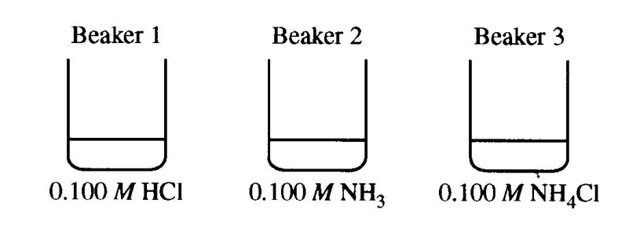
1. Each of three beakers contains 25.0 mL of a 0.100 M solution of HCl, NH₃, or NH₄Cl, as shown above. Each solution is at 25 ºC.

a.) Determine the pH of the solution in beaker 1. Justify your answer.

b.) In beaker 2, the reaction NH₃(aq) + H₂O(l) NH₄⁺(aq) + OH⁻(aq) occurs. The value of K_{b} for NH₃(aq) is 1.8 × 10⁻⁵ at 25 ºC.

i.) Write the K_{b} expression for the reaction of NH₃(aq) with H₂O(l).

ii.) Calculate the [OH⁻] in the solution in beaker 2.

c.) In beaker 3, the reaction NH₄⁺(aq) + H₂O(l) NH₃(aq) + H₃O⁺(aq) occurs.

i.) Calculate the value of K_{a} for NH₄⁺ at 25 ºC.

ii.) The contents of beaker 2 are poured into beaker 3 and the resulting solution is stirred. Assume that volumes are additive. Calculate the pH of the resulting solution.

d.) The contents of beaker 1 are poured into the solution made in part c) ii). The resulting solution is stirred. Assume that volumes are additive.

i.) Is the resulting solution an effective buffer? Justify your answer.

ii.) Calculate the final [NH₄⁺] in the resulting solution at 25 ºC.

1996 A/B lab #6

A 0.500-gram sample of a weak, nonvolatile acid, HA, was dissolved in sufficient water to make 50.0 milliliters of solution. The solution was then titrated with a standard NaOH solution. Predict how the calculated molar mass of HA would be affected (too high, too low, or not affected) by the following laboratory procedures. Explain each of your answers.

a. After rinsing the buret with distilled water, the buret is filled with the standard NaOH solution; the weak acid HA is titrated to its equivalence point.

b. Extra water is added to the 0.500-gram sample of HA.

c. An indicator that changes color at pH 5 is used to signal the equivalence point.

2000 #8 A/B Lab

A volume of 30.0 mL of 0.10 M NH₃(aq) is titrated with 0.20 M HCl(aq). The value of the base-dissociation constant, K_{b}, for NH₃ in water is 1.8 × 10⁻⁵ at 25 ºC.

a. Write the net-ionic equation for the reaction of NH₃(aq) with HCl(aq).

b. Using the axes provided below, sketch the titration curve that results when a total of 40.0 mL of 0.20 M HCl(aq) is added dropwise to the 30.0 mL volume of 0.10 M NH₃(aq).

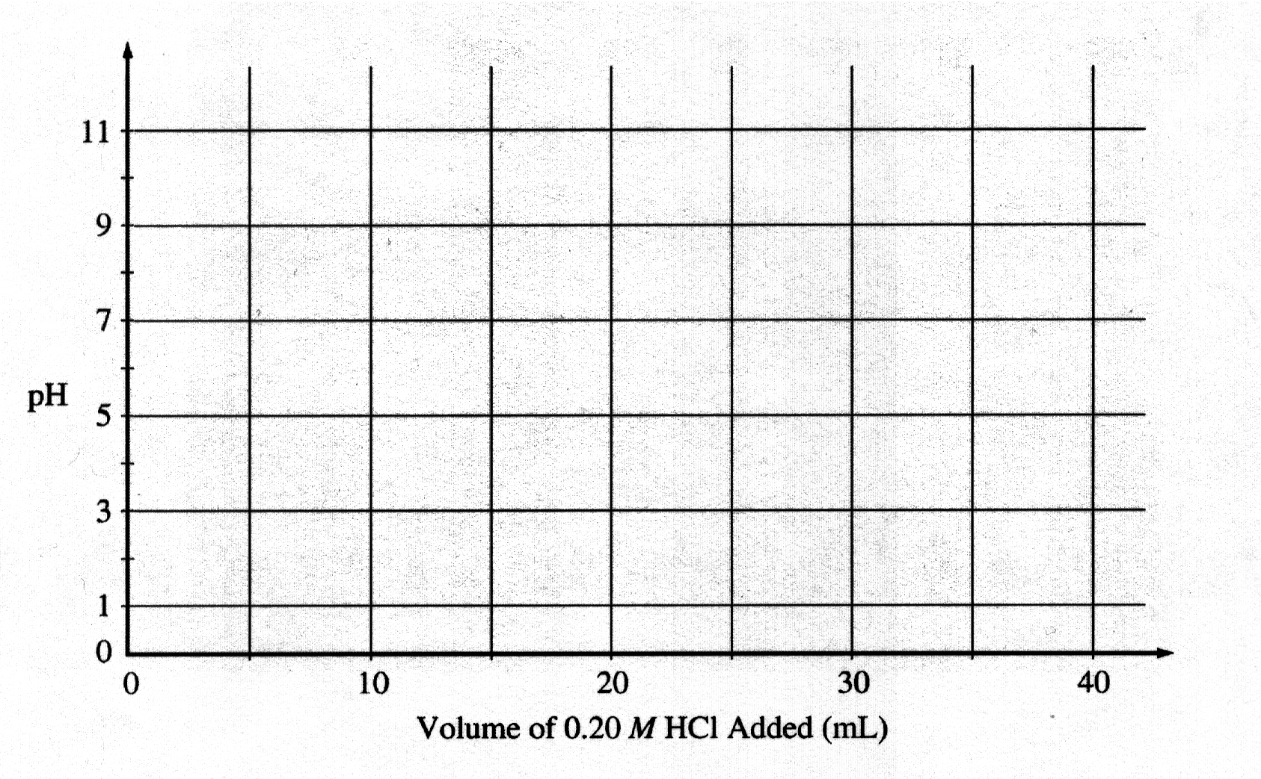
c. From the table below, select the most appropriate indicator for the titration. Justify your choice

Indicator | pK_{a}
Methyl Red | 5.5
Bromothymol Blue | 7.1
Phenolphthalein | 8.7

d. If equal volumes of 0.10 M NH₃(aq) and 0.10 M NH₄Cl(aq) are mixed, is the resulting solution acidic, neutral, or basic? Explain

2011B #1

1. Answer the following questions about the solubility and reactions of the ionic compounds M(OH)₂ and MCO₃, where M represents an unidentified metal.

a.) Identify the charge of the M ion in the ionic compounds above.

b.) At 25 ºC, a saturated solution of M(OH)₂ has a pH of 9.15.

i.) Calculate the molar concentration of OH⁻(aq) in the saturated solution.

ii.) Write the solubility product expression for M(OH)₂.

iii.) Calculate the value of the solubility product constant, K_{sp}, for M(OH)₂ at 25 ºC.

c.) For the metal carbonate, MCO₃, the value of the solubility product constant, K_{sp}, is 7.4 × 10⁻¹⁴ at 25 ºC. On the basis of this information and your results in part b), which compound, M(OH)₂ or MCO₃, has the greater molar solubility in water at 25 ºC? Justify your answer with a calculation.

d.) MCO₃ decomposes at high temperatures, as shown by the reaction represented below.

MCO₃(s) MO(s) + CO₂(g)

A sample of MCO₃ is placed in a previously evacuated container, heated to 423 K, and allowed to come to equilibrium. Some solid MCO₃ remains in the container. The value of K_{P} for the reaction at 423 K is 0.0012.

i.) Write the equilibrium constant expression for K_{P} of the reaction.

ii.) Determine the pressure, in atm, of CO₂(g) in the container at equilibrium at 423 K.

iii.) Indicate whether the value of ΔGº for the reaction at 423 K is positive, negative, or zero. Justify your answer.

2010 #1 Several reactions are carried out using AgBr, a cream-colored silver salt for which the value of the solubility-product constant, K_{sp}, is 5.0 × 10⁻¹³ at 298 K

a. Write the expression for the solubility-product constant, K_{sp}, of AgBr.

b. Calculate the value of [Ag⁺] in 50.0 mL of a saturated solution of AgBr at 298 K.

c. A 50.0 mL sample of distilled water is added to the solution described in part b, which is in a beaker with some solid AgBr at the bottom. The solution is stirred and equilibrium is reestablished. Some solid AgBr remains in the beaker. Is the value of [Ag⁺] greater than, less than, or equal to the value you calculated in part b? Justify your answer.

d. Calculate the minimum volume of distilled water, in liters, necessary to completely dissolve a 5.0 g sample of AgBr(s) at 298 K. (The molar mass of AgBr is 188 g mol⁻¹).

e. A student mixes 10.0 mL of 1.5 × 10⁻⁴ M AgNO₃ with 2.0 mL of 5.0 × 10⁻⁴ M NaBr and stirs the resulting mixture. What will the student observe? Justify your answer with calculations.

f. The color of another salt of silver, AgI(s) is yellow. A student adds a solution of NaI to a test tube containing a small amount of solid, cream-colored AgBr. After stirring the contents of the test tube, the student observes that the solid in the test tube changes color from cream to yellow.

i. Write the chemical equation for the reaction that occurred in the test tube.

ii. Which salt has the greater value of K_{sp}: AgBr or AgI? Justify your answer.

Multiple Choice Questions

2002 #64 Ascorbic acid, H₂C₆H₆O₆(s), is a diprotic acid with K₁ = 7.9 × 10⁻⁵ and K₂ = 1.6 × 10⁻¹². In a 0.005 M aqueous solution of ascorbic acid, which of the following species is present in the lowest concentration?

A) H₂O(l)
B) H₃O⁺(aq)
C) H₂C₆H₆O₆(aq)
D) HC₆H₆O₆⁻(aq)
E) C₆H₆O₆²⁻(aq)

2002 #33 Questions 33-34

The graph below shows the titration curve that results when 100. mL of 0.0250 M acetic acid is titrated with 0.100 M NaOH.

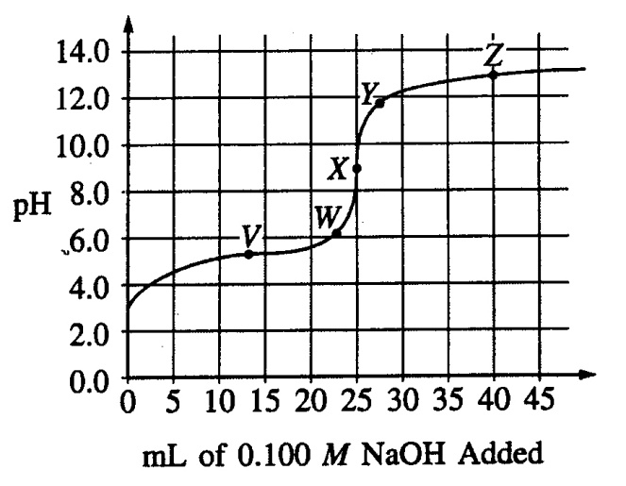

2002 #33. Which of the following indicators is the best choice for this titration?

pH Range of
Indicator Color Change
A) Methyl Orange 3.2-4.4
B) Methyl Red 4.8-6.0
C) Bromothymol blue 6.1-7.6
D) Phenolphthalein 8.2-10.0
E) Alizarin 11.0-12.4

2002 #34. Which part of the curve corresponds to the optimum buffer action for the acetic acid / acetate ion pair?

A) Point V
B) Point X
C) Point Z
D) Along all of section WY
E) Along all of section YZ

2008 #4-6
A solution of a weak monoprotic acid is titrated with a solution of a strong base, KOH. Consider the points labeled (A) through (E) on the titration curve that results, as shown below.
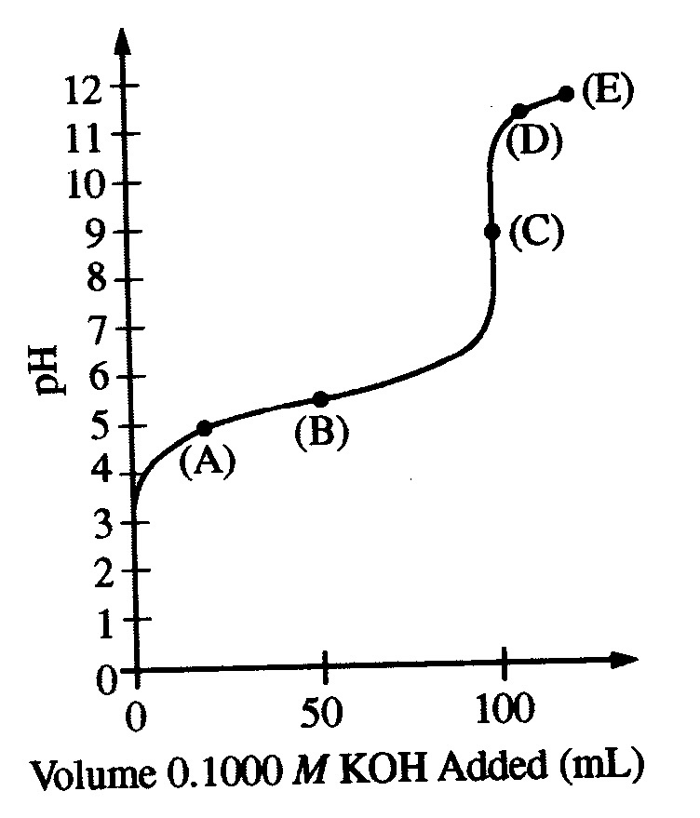
4. The point at which the moles of the added strong base are equal to the moles of the weak acid initially present
5. The point at which the pH is closest to that of a the strong base being added
6. The point at which the concentrations of the weak acid and its conjugate base are approximately equal

AP Chemistry Concepts List - KINETICS

1. Rate definition

2. Rate Law – differential versus integrated

3. Factors affecting rate

a. [C]
b. ΔT
c. catalysis
d. surface area
e. nature of reactants – distinguish between homo- and heterogenous
i. solids ii. Liquids iii. gases iv. Ions (solutions)

4. Collision theory – orientation and energy

5. Mechanism – relationship between ΔT, ΔS, ΔH – catalysis

6. Energy of activation (E_{a}) – Arrhenius equation – differentiate from ΔH

7. Order
a. determined by
i. experimental comparison
ii. graphing
b. zero, first, second – determining % remaining and/or % reacted
ex. Ln (x₂/x₁) = kt

8. Rate constants with units (units change with reaction order)
a. unsuccessful versus effective collisions
b. orientation and energy

9. Vocabulary

Reactants vs. products vs. catalyst vs. reaction intermediate

10. Mechanisms are consistent if:

- steps add up to balanced equation
- slow step of mechanism will define the mechanistic rate law and rate law expression
- no reaction intermediates in final rate law expression for comparison with the experimental rate law expression
Free Response Questions

1997 #4

2 A + B → C + D
The following results were obtained when the reaction represented above was studied at 25 °C
Experiment | Initial  [A] | Initial  [B] | Initial Rate of Formation of C  (mol L⁻¹ min⁻¹)
1 | 0.25 | 0.75 | 4.3 × 10⁻⁴
2 | 0.75 | 0.75 | 1.3 × 10⁻³
3 | 1.50 | 1.50 | 5.3 × 10⁻³
4 | 1.75 | ?? | 8.0 × 10⁻³

a. Determine the order of the reaction with respect to A and B. Justify your answer.

b. Write the rate law for the reaction. Calculate the value of the rate constant, specifying units.

c. Determine the initial rate of change of [A] in Experiment 3.

d. Determine the initial value of [B] in Experiment 4.

e. Identify which of the reaction mechanisms represented below is consistent with the rate law developed in part (b). Justify your choice.

1 | A + B → C + M | Fast
 | M + A → D | Slow
2 | B <===> M | Fast equilibrium
 | M + A → C + X | Slow
 | A + X → D | Fast
3 | A + B <===> M | Fast equilibrium
 | M + A → C + X | Slow
 | X → D | Fast

1999 # 3

2 NO(g) + Br₂(g) → 2 NOBr(g)

A rate study of the reaction represented above was conducted at 25°C. The data that were obtained are shown in the table below.

Experiment | Initial [NO]  (mol L⁻¹) | Initial [Br₂]  (mol L⁻¹) | Initial Rate of Appearance  of NOBr (mol L⁻¹ s⁻¹)
1 | 0.0160 | 0.0120 | 3.24 × 10⁻⁴
2 | 0.0160 | 0.0240 | 6.38 × 10⁻⁴
3 | 0.0320 | 0.0060 | 6.42 × 10⁻⁴

a. Calculate the initial rate of disappearance of Br₂(g) in experiment 1.

b. Determine the order of the reaction with respect to each reactant, Br₂(g) and NO(g). In each case, explain your reasoning.

c. For the reaction,

i. write the rate law that is consistent with the data, and

ii. calculate the value of the specific rate constant, k, and specify units.

d. The following mechanism was proposed for the reaction:

Br₂(g) + NO(g) → NOBr₂(g) slow

NOBr₂(g) + NO(g) → 2 NOBr(g) fast

Is this mechanism consistent with the given experimental observations? Justify your answer.

1996 # 8

The reaction between NO and H₂ is believed to occur in the following three-step process.
NO + NO <===> N₂O₂ (fast)
N₂O₂ + H₂ → N₂O + H₂O (slow)
N₂O + H₂ → N₂ + H₂O (fast)

a. Write a balanced equation for the overall reaction.

b. Identify the intermediates in the reaction. Explain your reasoning.

c. From the mechanism represented above, a student correctly deduces that the rate law for the reaction is rate = k[NO]²[H₂]. The student then concludes that (1) the reaction is third-order and (2) the mechanism involves the simultaneous collision of two NO molecules and an H₂ molecule. Are conclusions (1) and (2) correct? Explain.

d. Explain why an increase in temperature increases the rate constant, k, given the rate law in part c.

1998 #6

Answer the following questions regarding the kinetics of chemical reactions.

a. The diagram below at right shows the energy pathway for the reaction O₃ + NO → NO₂ + O₂.

Clearly label the following directly on the diagram.
i. The activation energy (E_{a}) for the forward reaction
ii. The enthalpy change (ΔH) for the reaction
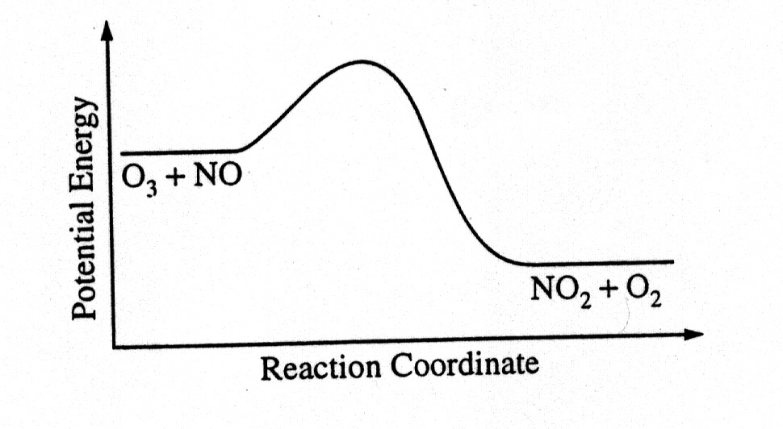
b. The reaction 2 N₂O₅ → 4 NO₂ + O₂ is first order with respect to N₂O₅.

i. Using the axes at right, complete the graph that represents the change in [N₂O₅] over time as the reaction proceeds.
ii. Describe how the graph in part i could be used to find the reaction rate at a given time, t.
iii Considering the rate law and the graph in part i, describe how the value of the rate constant, k, could be determined.
iv. If more N₂O₅ were added to the reaction mixture at constant temperature, what would be the effect on the rate constant, k? Explain.
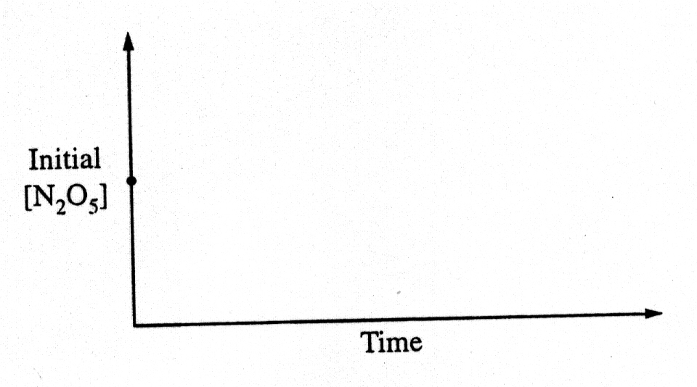

c. Data for the chemical reaction 2A → B + C were collected by measuring the concentration of A at 10-minute intervals for 80 minutes. The following graphs were generated from analysis of data.

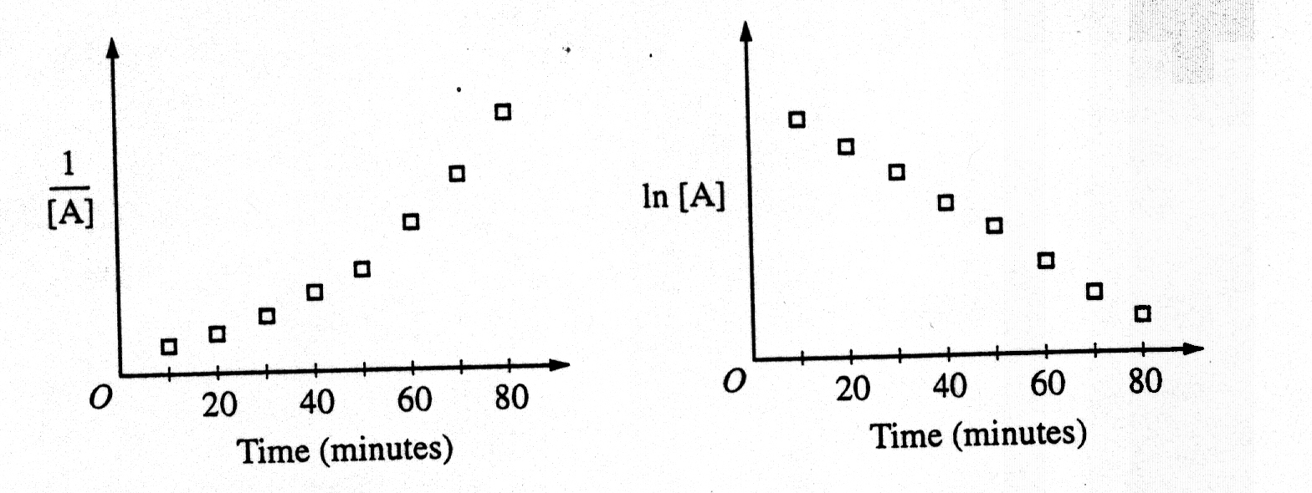

Use the information in the graphs above to answer the following.
i. Write the rate-law expression for the reaction. Justify your answer.
ii. Describe how to determine the value of the rate constant for the reaction.

Multiple Choice Questions

1999 #36
Experiment | Initial [NO]  (mol L⁻¹ ) | Initial [O₂]  (mol L⁻¹) | Initial Rate of  Formation of NO₂  (mol L⁻¹ s⁻¹)
1 | 0.10 | 0.10 | 2.5 × 10⁻⁴
2 | 0.20 | 0.10 | 5.0 × 10⁻⁴
3 | 0.20 | 0.40 | 8.0 × 10⁻³
The initial-rate data in the table above were obtained for the reaction represented below. What is the experimental rate law for the reaction?
A) rate = k[NO] [O₂]
B) rate = k[NO] [O₂]²
C) rate = k[NO]² [O₂]
D) rate = k[NO]² [O₂]²
E) rate = k[NO] / [O₂]

2008 #32 Gaseous cyclobutene undergoes a first-order reaction to form gaseous butadiene. At a particular temperature, the partial pressure of cyclobutene in the reaction vessel drops to one-eighth its original value in 124 seconds. What is the half-life for this reaction at this temperature?

A) 15.5 sec
B) 31.0 sec
(C) 41.3 sec
(D) 62.0 sec
(E) 124 sec

1999 #63
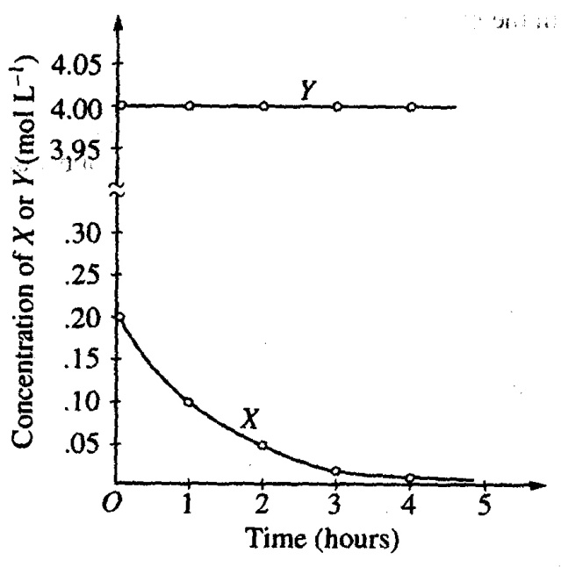
The graph above shows the results of a study of the reaction of X with a large excess of Y to yield Z. The concentrations of X and Y were measured over a period of time. According to the results, which of the following can be concluded about the rate of law for the reaction under the conditions studied?
A) It is zero order in [X].
B) It is first order in [X].
C) It is second order in [X].
D) It is the first order in [Y].
E) The overall order of the reaction is 2.

2002 #27 2 NO(g) + O₂(g) 2 NO₂(g)

A possible mechanism for the overall reaction represented above is the following

(1) NO(g) + NO(g) N₂O₂(g) slow
(2) N₂O₂(g) + O₂(g) 2 NO₂(g) fast

Which of the following rate expressions agrees best with this possible mechanism?

A) Rate = k [NO]²
B) Rate = k [NO] / [O₂]
C) Rate = k [NO]² / [O₂]
D) Rate = k [NO]² [O₂]
E) Rate = k [N₂O₂] [O₂]

2002 #54 Which of the following must be true for a reaction for which the activation energy is the same for both the forward and reverse reactions?

A) A catalyst is present.
B) The reaction order can be obtained directly from the balanced equation.
C) The reaction order is zero.
D) ΔH for the reaction is zero.
E) ΔS for the reaction is zero.

AP Chemistry Concepts - ELECTROCHEMISTRY

1. oxidation / reduction – balancing equations (review)

2. galvanic cells – {positive, Red Cat}

3. electrolytic cells

4. cathode

5. anode

6. current, charge, Faradays, (voltage / EMF) (amps, coulombs and volts – unit problem)

7. cell notation

8. salt bridge – “balance of charge” not electron balance,
Good salt bridge materials are soluble salts, not easily oxidized or reduced, doesn’t interfere with given redox reaction, ie complex ion formation or precipitation

9. Eº and spontaneity

10. ΔGº = - n F Eº

11. E = Eº – (0.059 / n) log K_{c}

12. Vocabulary –

Galvanic
Voltaic

Free Response Questions

2007 #3.
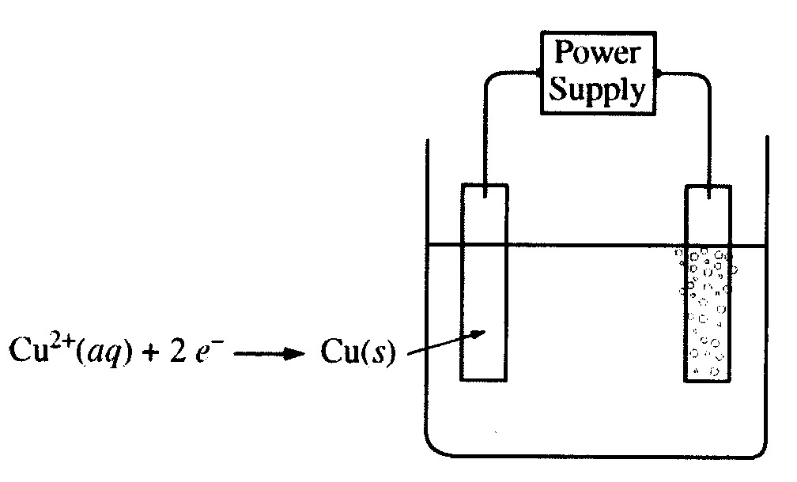

An external direct-current power supply is connected to two platinum electrodes immersed in a beaker containing 1.0 M CuSO₄(aq) at 25ºC, as shown in the diagram above. As the cell operates, copper metal is deposited onto one electrode and O₂(g) is produced at the other electrode. The two reduction half-reactions for the overall reaction that occurs in the cell are shown in the table below.

half-reaction Eº(V)
O₂(g) + 4 H⁺(aq) + 4 e⁻ 2H₂O(l) +1.23
Cu²⁺(aq) + 2e⁻ Cu(s) +0.34

a. On the diagram, indicate the direction of electron flow in the wire.

b. Write a balanced net ionic equation for the electrolysis reaction that occurs in the cell.

c. Predict the algebraic sign of ΔGº for the reaction. Justify your prediction.

d. Calculate the value of ΔGº for the reaction.

An electric current of 1.50 amps passes through the cell for 40.0 minutes.

e. Calculate the mass, in grams, of the Cu(s) that is deposited on the electrode.

f. Calculate the dry volume, in liters measured at 25ºC and 1.16 atm, of the O₂(g) that is produced.

1997 #3

In an electrolytic cell, a current of 0.250 ampere is passed through a solution of a chloride of iron, producing Fe(s) and Cl₂(g).

a. Write the equation for the reaction that occurs at the anode.

b. When the cell operates for 2.00 hours, 0.521 gram of iron is deposited at one electrode. Determine the formula of the chloride of iron in the original solution.

c. Write the balanced equation for the overall reaction that occurs in the cell.

d. How many liters of Cl₂(g), measured at 25 °C and 750 mmHg, are produced when the cell operates as described in part (b)?

e. Calculate the current that would produce chlorine gas at a rate of 3.00 grams per hour.

2000 # 2

Answer the following questions that relate to electrochemical reactions.

a. Under standard conditions at 25 ºC, Zn(s) reacts with Co²⁺(aq) to produce Co(s)

i) Write the balanced equation for the oxidation half reaction.

ii) Write the balanced net-ionic equation for the overall reaction.

iii) Calculate the standard potential, Eº, for the overall reaction at 25 ºC.

b. At 25 ºC, H₂O₂ decomposes according to the following equation.

2 H₂O₂(aq) 2 H₂O(l) + O₂(g) Eº = 0.55 V

i) Determine the value of the standard free energy change, ΔGº, for the reaction at 25 ºC.

ii) Determine the value of the equilibrium constant, K_{eq}, for the reaction at 25 ºC.

iii) The standard reduction potential, Eº, for the half reaction O₂(g) + 4 H⁺(aq) + 4e⁻ 2 H₂O(l) has a value of 1.23 V. Using this information in addition to the information given above, determine the value of the standard reduction potential, Eº, for the half reaction below.

O₂(g) + 2 H⁺(aq) + 2e⁻ H₂O₂(aq)

c. In an electrolytic cell, Cu(s) is produced by the electrolysis of CuSO₄(aq). Calculate the maximum mass of Cu(s) that can be deposited by a direct current of 100. amperes passed through 5.00 L of 2.00 M CuSO₄(aq) for a period of 1.00 hour.

1996 #7 Sr(s) + Mg²⁺ Sr²⁺ + Mg(s)

Consider the reaction represented above that occurs at 25°C. All reactants and products are in their standard states. The value of the equilibrium constant, K_{eq}, for the reaction is 4.2 × 10¹⁷ at 25°C.

a. Predict the sign of the standard cell potential, E°, for a cell based on the reaction. Explain your prediction.

b. Identify the oxidizing agent for the spontaneous reaction.

c. If the reaction were carried out at 60°C instead of 25°C, how would the cell potential change? Justify your answer.

d. How would the cell potential change if the reaction were carried out at 25°C with a 1.0 M solution of Mg(NO₃)₂ and a 0.10 M solution of Sr(NO₃)₂? Explain.

e. When the cell reaction in part d reaches equilibrium, what is the cell potential?

1998 #8

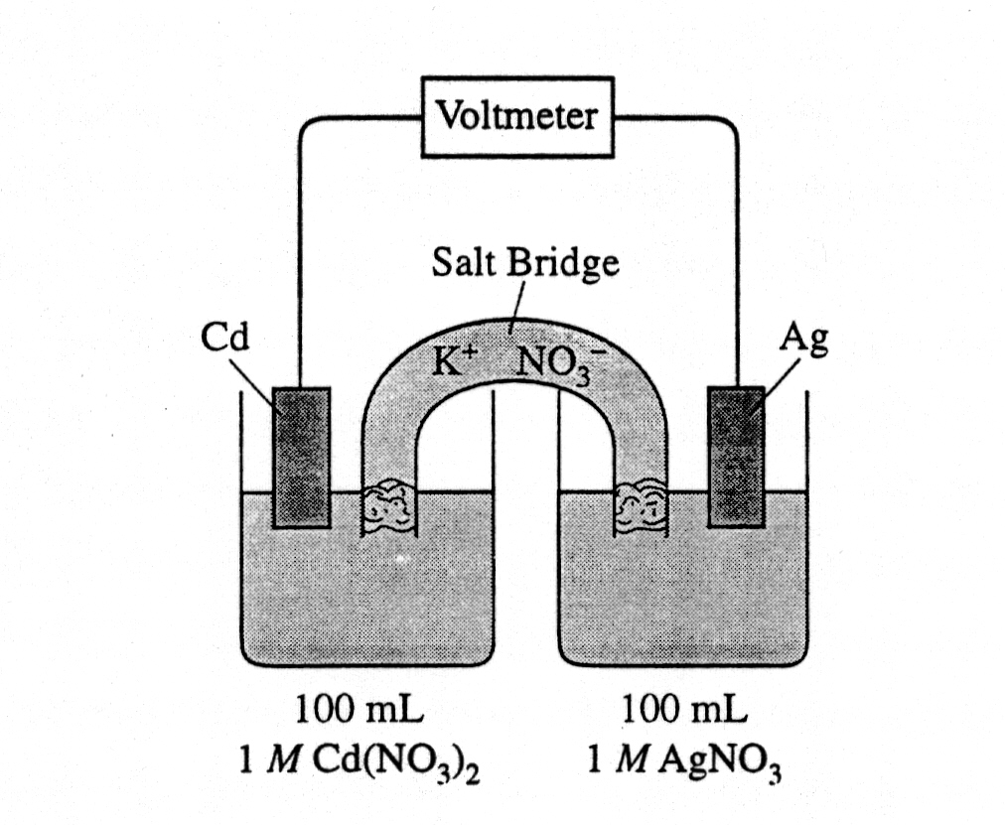

Answer the following questions regarding the electrochemical cell shown above.
a. Write the balanced net-ionic equation for the spontaneous reaction that occurs as the cell operates, and determine the cell voltage.

b. In which direction do anions flow in the salt bridge as the cell operates? Justify your answer.

c. If 10.0 mL of 3.0-molar AgNO₃ solution is added to the half-cell on the right, what will happen to the cell voltage? Explain.

d. If 1.0 grams of solid NaCl is added to each half-cell, what will happen to the cell voltage? Explain.

e. If 20.0 mL of distilled water is added to both half-cells, the cell voltage decreases. Explain.

2002 # 2

Answer parts (a) through (e) below, which relate to reactions involving silver ion, Ag⁺.

The reaction between silver ion and solid zinc is represented by the following equation

2 Ag⁺(aq) + Zn(s) → Zn²⁺(aq) + 2 Ag(s)

a. A 1.50 g sample of Zn is combined with 250. mL of 0.110 M AgNO₃ at 25 ºC.

i. Identify the limiting reactant. Show calculations to support your answer.

ii. On the basis of the limiting reactant that you identified in part (i), determine the value of [Zn²⁺] after the reaction is complete. Assume that volume change is negligible.

b. Determine the value of the standard potential, Eº, for a galvanic cell based on the reaction between AgNO₃(aq) and solid Zn at 25 ºC.

Another galvanic cell is based on the reaction between Ag⁺(aq) and Cu(s), represented by the equation below. At 25 ºC, the standard potential, Eº, for the cell is 0.46 V.

2 Ag⁺(aq) + Cu(s) Cu²⁺(aq) + 2 Ag(s)

c. Determine the value of the standard free-energy change, ΔGº, for the reaction between Ag⁺(aq) and Cu(s) at 25 ºC.

d. The cell is constructed so that [Cu²⁺] is 0.045 M and [Ag⁺] is 0.010 M. Calculate the value of the potential, E, for the cell.

e. Under the conditions specified in part (d), is the reaction in the cell spontaneous? Justify your answer.

2001 # 7

Answer the following questions that refer to the galvanic cell shown in the diagram below. (A table of standard reduction potentials is printed on the green insert and on page 4 of the booklet with the pink cover.)

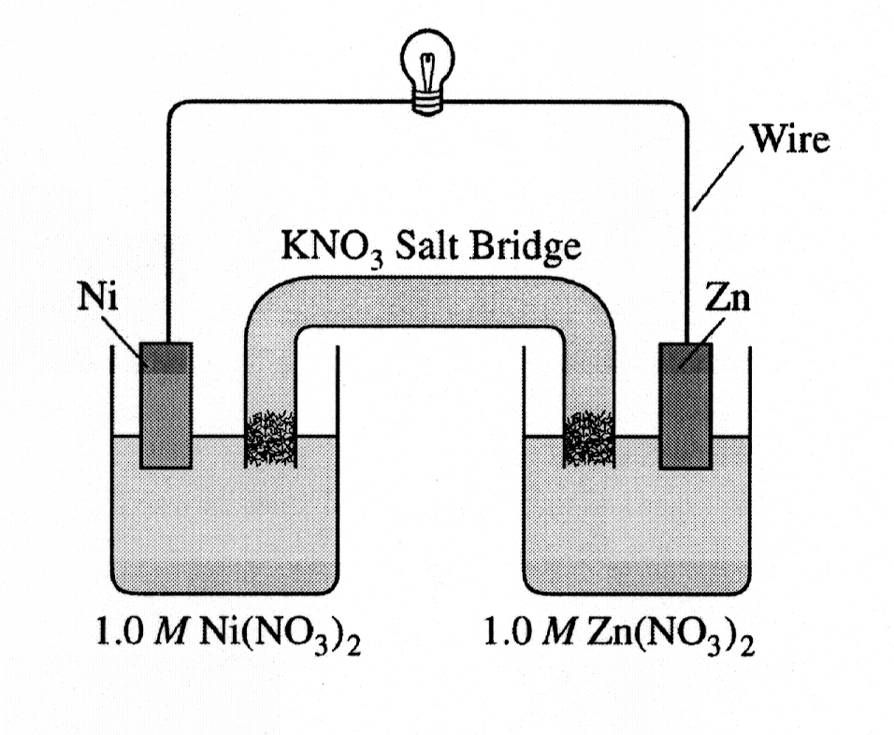
a. Identify the anode of the cell and write the half-reaction that occurs there.

b. Write the net ionic equation for the overall reaction that occurs as the cell operates and calculate the value of the standard cell potential, Eº_{cell}.

c. Indicate how the value of E_{cell} would be affected if the concentration of Ni(NO₃)₂(aq) was changed from 1.0 M to 0.10 M and the concentration of Zn(NO₃)₂(aq) remained at 1.0 M. Justify your answer.

d. Specify whether the value of K_{eq} for the cell reaction is less than 1, greater than 1, or equal to 1. Justify your answer.

2003B # 6

Answer the following questions about electrochemistry.

a. Several different electrochemical cells can be constructed using the materials shown below. Write the balanced net-ionic equation for the reaction that occurs in the cell that would have the greatest positive value of E_{cell}º.

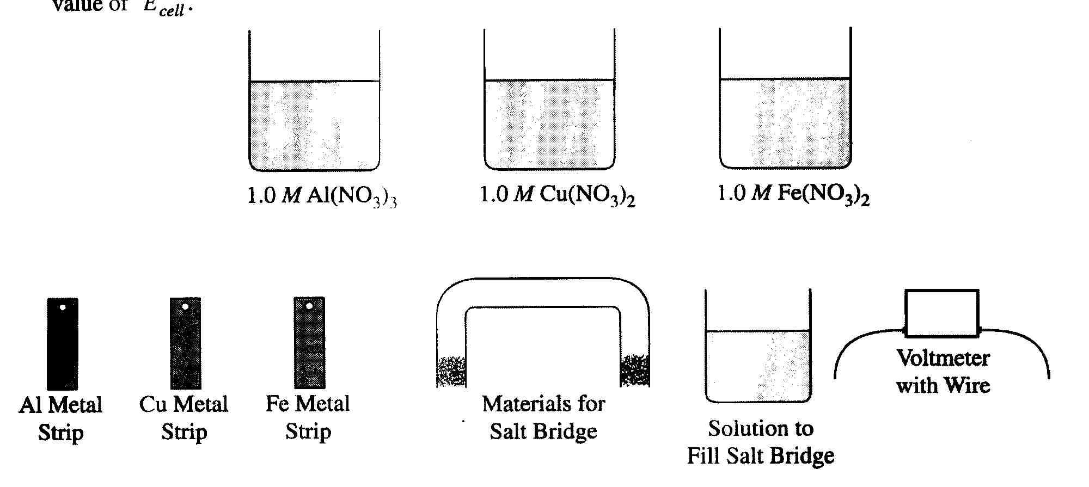
b. Calculate the standard cell potential, E_{cell}º, for the reaction written in part a.

c. A cell is constructed based on the reaction in part a above. Label the metal used for the anode on the cell shown in the figure below.

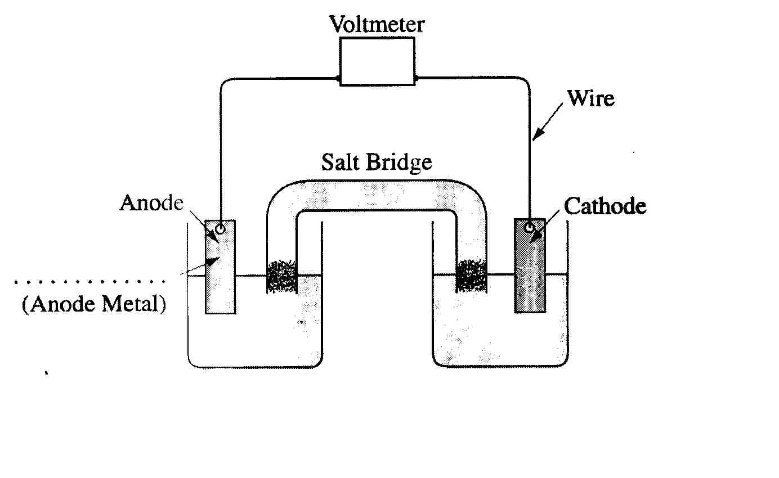

d. Of the compounds, NaOH, CuS, and NaNO₃, which one is appropriate to use in a salt bridge? Briefly explain your answer, and for each of the other compounds, include a reason why it is not appropriate.

e. Another standard cell is based on the following reaction.

Zn + Pb²⁺ Zn²⁺ + Pb

If the concentration of Zn²⁺ is decreased from 1.0 M to 0.25 M, what effect does this have on the cell potential? Justify your answer.

Multiple Choice Questions

1999 #20 What mass of Au is produced when 0.0500 mol of Au₂S₃ is reduced completely with excess H₂?
A) 9.85 g
B) 19.7 g
C) 24.5 g
D) 39.4 g
E) 48.9 g

1999 #57
M(s) + 3 Ag⁺(aq) 3 Ag(s) + M³⁺(aq) | E = +2.46 V
Ag⁺(aq) + e¯ Ag(s) | E = +0.80 V
According to the information above, what is the standard reduction potential for the half-reaction M³⁺(aq) + 3 e¯ M(s)?
A) -1.66 V
B) -0.06 V
C) 0.06 V
D) 1.66 V
E) 3.26 V
2002 #38 A 0.10 M aqueous solution of sodium sulfate, Na₂SO₄, is a better conductor of electricity than a 0.10 M aqueous solution of sodium chloride, NaCl. Which of the following best explains this observation?

A) Na₂SO₄ is more soluble in water than NaCl is.
B) Na₂SO₄ has a higher molar mass than NaCl has.
C) To prepare a given volume of 0.10 M solution, the mass of Na₂SO₄ needed is more than twice the mass of NaCl needed.
D) More moles of ions are present in a given volume of 0.10 M Na₂SO₄ than in the same volume of 0.10 M NaCl.
E) The degree of dissociation of Na₂SO₄ in solution is significantly greater than that of NaCl.

2008 #44 Cl₂(g) + 2 I⁻(aq) 2 Cl⁻(aq) + I₂(aq)
Which of the following best accounts for the fact that a galvanic cell based on the reaction represented above will generate electricity?

A) Cl₂ can easily lose two electrons.
B) Cl₂ is a stronger oxidizing agent than I₂
C) I atoms have more electrons than do atoms of Cl
D) I⁻ is a more stable species than I₂
E) I₂(s) is more soluble than Cl₂(g)

2008 #74 An electric current of 1.00 ampere is passed through an aqueous solution of Ni(NO₃)₂. How long will it take to plate out exactly 1.00 mol of nickel metal, assuming 100 percent current efficiency? (1 faraday = 96,500 coulombs = 6.02 × 10²³ electrons)

A) 386,000 sec
B) 193,000 sec
C) 96,500 sec
D) 48,200 sec
E) 24,100 sec

AP Chemistry Concepts - THERMODYNAMICS

1. ∆H⁰ _{rxn} = ∑ ∆ H_{f} ⁰Products - ∑∆ H_{f}⁰ Reactants

= ∑ Bond Energy Reactants - ∑ Bond energy Products

∆H_{rxn} - exothermic ∆H_{rxn} + endothermic

2. ∆S⁰ _{rxn} = ∑ S_{f}⁰ Products - ∑ S_{f}⁰ Reactants

∆S⁰_{rxn} - ordered ∆S⁰_{rxn} + disordered

3. ∆G⁰ _{rxn} = ∆H⁰_{rxn} - T ∆S ⁰_{rxn}

∆G⁰_{rxn} - spontaneous ∆G⁰_{rxn} + nonspontaneous

4. ∆G⁰_{rxn} = - RT ln Q Q = K_{eq} free energy and equilibrium

5. ∆G⁰ _{rxn} = - nF E⁰ free energy and electrochemistry

F = 96,500 coulombs / mole electrons
Faraday’s constant

6. Phase diagrams

7. ∆H _{rxn} = q = m ( c ) ( ∆T )

Free Response Questions

1998 # 3 C₆H₅OH(s) + 7 O₂(g) → 6 CO₂(g) + 3H₂O(l)

When a 2.000-gram sample of pure phenol, C₆H₅OH(s), is completely burned according to the equation above, 64.98 kilojoules of heat is released. Use the information in the table below to answer the questions that follow.

Substance | Standard Heat of Formation, ΔH°_{f}, at 25°C (kJ/mol) | Absolute Entropy, S°, at 25°C (J/mol-K)
C(graphite) | 0.00 | 5.69
CO₂(g) | -395.5 | 213.6
H₂(g) | 0.00 | 130.6
H₂O(l) | -285.85 | 69.91
O₂(g) | 0.00 | 205.0
C₆H₅OH(s) | ? | 144.0

a. Calculate the molar heat of combustion of phenol in kilojoules per mole at 25°C.

b. Calculate the standard heat of formation, ΔH°_{f}, of phenol in kilojoules per mole at 25°C.

c. Calculate the value of the standard free-energy change, ΔG° for the combustion of phenol at 25°C.

d. If the volume of the combustion container is 10.0 liters, calculate the final pressure in the container when the temperature is changed to 110°C. (Assume no oxygen remains unreacted and that all products are gaseous.)

1996 #3 C₂H₂(g) + 2 H₂(g) → C₂H₆(g)

Information about the substances
Substance S° (J/mol K) ΔH°_{f} (kJ/mol) Bond Bond Energy (kJ/mol)

C₂H₂(g) 200.9 226.7 C-C 347
H₂(g) 130.7 0 C=C 611
C₂H₆(g) -------- -84.7 C-H 414
H-H 436

a. If the value of the standard entropy change, ΔS°, for the reaction is -232.7 joules per mole Kelvin, calculate the standard molar entropy, S°, of C₂H₆ gas.

b. Calculate the value of the standard free-energy change, ΔG°, for the reaction. What does the sign of ΔG° indicate about the reaction above?

c. Calculate the value of the equilibrium constant, K, for the reaction at 298 K.

d. Calculate the value of the C ≡ C bond energy in C₂H₂ in kilojoules per mole.

1997 #7

For the gaseous equilibrium represented below, it is observed that greater amounts of PCl₃ and Cl₂ are produced as the temperature is increased.

PCl₅(g) PCl₃(g) + Cl₂(g)

a. What is the sign of ΔS° for the reaction? Explain.

b. What change, if any, will occur in ΔG° for the reaction as the temperature is increased. Explain your reasoning in terms of thermodynamic principles.

c. If He gas is added to the original reaction mixture at constant volume and temperature, what will happen to the partial pressure of Cl₂? Explain.

d. If the volume of the original reaction is decreased at constant temperature to half the original volume, what will happen to the number of moles of Cl₂ in the reaction vessel? Explain.

1999 # 6

Answer the following questions in terms of thermodynamic principles and concepts of kinetic molecular theory.

a. Consider the reaction represented below, which is spontaneous at 298 K.

CO₂(g) + 2 NH₃(g) → CO(NH₂)₂(s) + H₂O(l); ΔH°₂₉₈ = -134 kJ

i. For the reaction, indicate whether the standard entropy change, ΔS°₂₉₈, is positive, or negative, or zero. Justify your answer.

ii. Which factor, the change in enthalpy, ΔH°₂₉₈, or the change in entropy, ΔS°₂₉₈, provides the principal driving force for the reaction at 298 K? Explain.

iii. For the reaction, how is the value of the standard free energy change, ΔG°, affected by an increase in temperature? Explain.

b. Some reactions that are predicted by their sign of ΔG° to be spontaneous at room temperature do not proceed at a measurable rate at room temperature.

i. Account for this apparent contradiction.

ii. A suitable catalyst increases the rate of such a reaction. What effect does the catalyst have on ΔG° for the reaction? Explain.

2002 # 8

Carbon (graphite), carbon dioxide, and carbon monoxide form an equilibrium mixture, as represented by the equation

C(s) + CO₂(g) 2CO(g)

a. Predict the sign for the change in entropy, ΔS, for the reaction. Justify your prediction.

b. In the table below are data that show the percent of CO in the equilibrium mixture at two different temperatures. Predict the sign for the change in enthalpy, ΔH, for the reaction. Justify your prediction.

Temperature % CO
700 ºC 60
850 ºC 94

c. Appropriately complete the potential energy diagram for the reaction by finishing the curve on the graph below. Also, clearly indicate ΔH for the reaction on the graph.

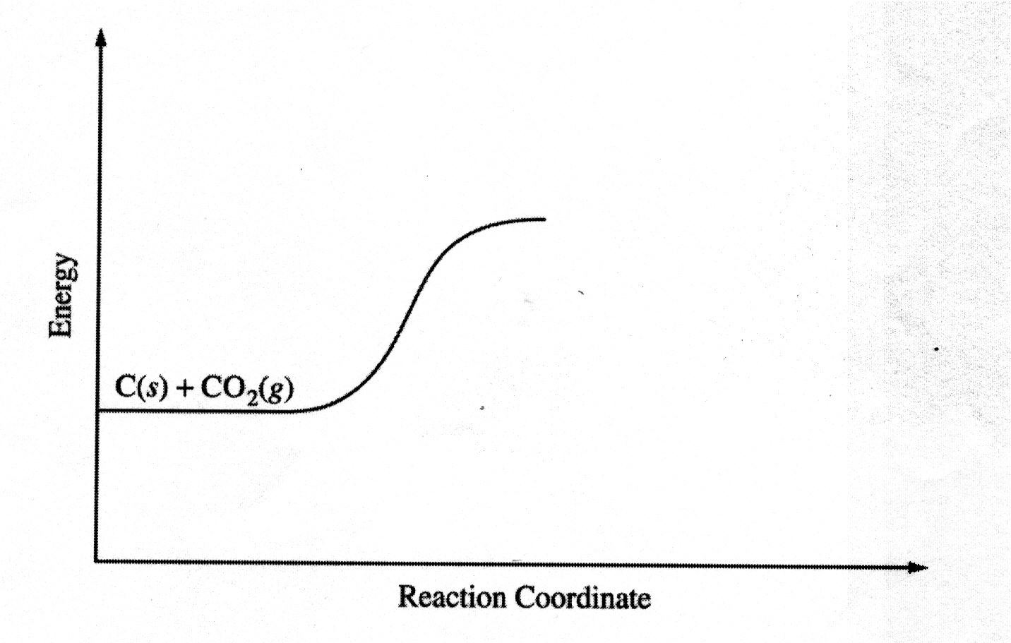

d. If the initial amount of C(s) were doubled, what would be the effect on the percent of CO in the equilibrium mixture? Justify your answer.

2010 #2.

A student performs an experiment to determine the molar enthalpy of solution of urea, H₂NCONH₂. The student places 91.95 g of water at 25 ºC into a coffee-cup calorimeter and immerses a thermometer in the water. After 50 s, the student adds 5.13 g of solid urea, also at 25 ºC, to the water and measures the temperature of the solution as the urea dissolves. A plot of the temperature data is shown in the graph below.
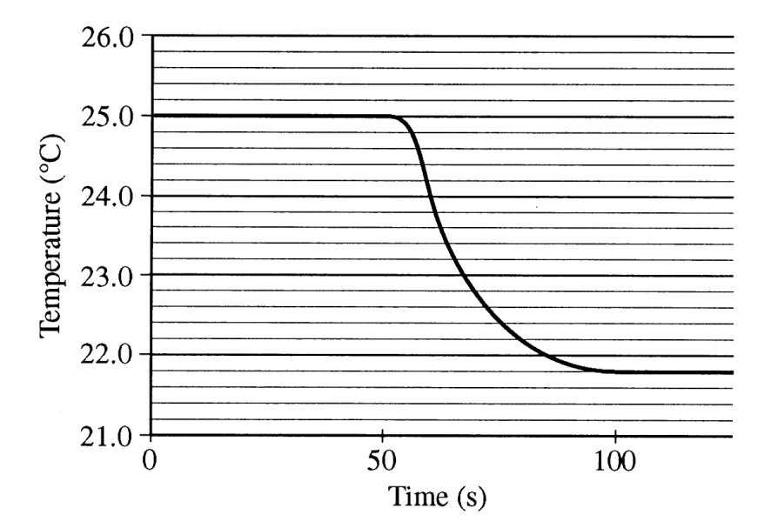
a. Determine the change in temperature of the solution that results from the dissolution of the urea.

b. According to the data, is the dissolution of urea in water an endothermic process or an exothermic process? Justify your answer.

c. Assume that the specific heat capacity of the calorimeter is negligible and that the specific heat capacity of the solution of urea and water is 4.2 J g⁻¹ ºC⁻¹ throughout the experiment.

i. Calculate the heat of dissolution of the urea in joules.
ii. Calculate the molar enthalpy of solution, ΔH_{soln}º, of urea in kJ mol⁻¹.
d. Using the information in the table below, calculate the value of the molar entropy of solution, ΔS_{soln}º, of urea at 298 K. Include units with your answer.
Accepted value
ΔH_{soln}º of urea 14.0 kJ mol⁻¹
ΔG_{soln}º of urea -6.9 kJ mol⁻¹

e. The student repeats the experiment and this time obtains a result for ΔH_{soln}º of urea that is 11 percent below the accepted value. Calculate the value of ΔH_{soln}º that the student obtained in this second trial.

f. The student performs a third trial of the experiment but this time adds urea that has been taken directly from a refrigerator at 5 ºC. What effect, in any, would using the cold urea instead of urea at 25 ºC have on the experimentally obtained value of ΔH_{soln}º? Justify your answer.

Multiple Choice Questions

1999 #61 C₂H₄(g) + 3 O₂(g) 2 CO₂(g) + 2 H₂O(g)
For the reaction of ethylene represented above, ΔH is - 1,323 kJ. What is the value of ΔH if the combustion produced liquid water H₂O(l), rather than water vapor H₂O(g)? (ΔH for the phase change H₂O(g) H₂O(l) is -44 kJ mol⁻¹.)
A) -1,235 kJ
B) -1,279 kJ
C) -1,323 kJ
D) -1,367 kJ
E) -1,411 kJ

2002 #25 3 C₂H₂(g) C₆H₆(g)

What is the standard enthalpy change, ΔHº, for the reaction represented above? (ΔHº_{f} of C₂H₂(g) is 230 kJ mol⁻¹; ΔHº_{f} of C₆H₆(g) is 83 kJ mol⁻¹.)

A) -607 kJ
B) -147 kJ
C) -19 kJ
D) +19 kJ
E) +773 kJ

1999 #22 Of the following reactions, which involves the largest decrease in entropy?
A) CaCO₃(s) CaO(s) + CO₂(g)
B) 2 CO(g) + O₂(g) 2 CO₂
C) Pb(NO₃)₃ + 2 KI PbI₂ + 2 KNO₃
D) C₃H₈ + O₂ 3 CO₂ + 4 H₂O
E) 4 La + 3 O₂ 2 La₂O₃

2002 #41 When solid NH₄SCN is mixed with solid Ba(OH)₂ in a closed container, the temperature drops and a gas is produced. Which of the following indicates the correct signs for ΔG, ΔH, and ΔS for the process?

ΔG ΔH ΔS

A) - - -
B) - + -
C) - + +
D) + - +
E) + - -

2002 #73 X(s) X(l)

Which of the following is true for any substance undergoing the process represented above at its normal melting point?

A) ΔS < 0
B) ΔH = 0
C) ΔH = TΔG
D) TΔS = 0
E) ΔH = TΔS

AP Chemistry Concepts - ATOMIC THEORY, BONDING AND INTERMOLECULAR FORCES

1. Quantum Numbers, electron configurations, Hund’s rule, orbital diagrams

2. ionic bonds

3. Covalent bonds, Lewis structures, geometric shapes, bond polarity, molecular
polarity, resonance, hybridization, London dispersion forces (LDF), inter vs. intramolecular forces

4. Trends of the periodic table a) size for atoms and ions b) size of ions
c) IE, EA, EN

5. Effective nuclear charge (Z_{eff} ) increases as more protons added to same
energy level Z_{eff} is a comparison tool.

6. Effective nuclear charge (Z_{eff} ) decreases as more shielding electrons are
present.

7. Intermolecular Forces (IMF) are between molecules and help explain
differences in FP, BP, solids, liquids, gases, and solubilities.
  - ion – ion
  - dipole – dipole with H bonding
  - dipole – dipole
  - London dispersion forces ( LDF )

8. When students talk about EN differences they are talking about bonds
(within a molecule), we need them to talk about IMF (between molecules )

9. Students often talk about atoms “wanting to gain/lose electrons”, being happy,
Full, rather than having a stable octet, complete energy level.

10. Vocabulary

IE (ionization energy)
EN (electronegativity)
EA (electron affinity)

Free Response Questions

1996 # 9

Explain each of the following in terms of the electronic structure and/or bonding of the compounds involved.

a. At ordinary conditions, HF (normal boiling point = 20°C) is a liquid, whereas HCl (normal boiling point = -114°C) is a gas.

b. Molecules of AsF₃ are polar, whereas molecules of AsF₅ are nonpolar.

c. The N-O bonds in the NO₂¯ ion are equal in length, whereas they are unequal in HNO₂.

d. For sulfur, the fluorides SF₂, SF₄, and SF₆ are known to exist, whereas for oxygen only OF₂ is known to exist.

1999 # 8

Answer the following questions using principles of chemical bonding and molecular structure.

a. Consider the carbon dioxide molecule, CO₂, and the carbonate ion, CO₃²⁻.

i. Draw the complete Lewis electron-dot structure for each species.

ii. Account for the fact that the carbon-oxygen bond length in CO₃²⁻ is greater than the carbon-oxygen bond length in CO₂.

b. Consider the molecules CF₄ and SF₄.
i. Draw the complete Lewis electron-dot structure for each molecule.

ii. In terms of molecular geometry, account for the fact that the CF₄ molecule is nonpolar, whereas the SF₄ molecule is polar.

1997 # 6

Explain each of the following observations using principles of atomic structure and/or bonding.

a. Potassium has a lower first-ionization energy than lithium.

b. The ionic radius of N³⁻ is larger than that of O²⁻.

c. A calcium atom is larger than a zinc atom.

d. Boron has a lower first-ionization energy than beryllium.

2000 # 7

Answer the following questions about the element selenium, Se (atomic number 34).

a. Samples of natural selenium contain six stable isotopes. In terms of atomic structure, explain what these isotopes have in common, and how they differ.

b. Write the complete electron configuration (e.g., 1s² 2s² … etc.) for a selenium atom in the ground state. Indicate the number of unpaired electrons in the ground-state atom, and explain your reasoning.

c. In terms of atomic structure, explain why the first ionization energy of selenium is

i. less than that of bromine (atomic number 35), and

ii. greater than that of tellurium (atomic number 52).

d. Selenium reacts with fluorine to form SeF₄. Draw the complete Lewis electron-dot structure for SeF₄ and sketch the molecular structure. Indicate whether the molecule is polar or nonpolar, and justify your answer.

2003 # 8

Using the information in the table, answer the following questions about organic compounds.

Compound Name Compound Formula ΔH_{vap}º (kJ mol⁻¹)

Propane CH₃CH₂CH₃ 19.0
Propanone CH₃COCH₃ 32.0
1-propanol CH₃CH₂CH₂OH 47.3

a. For propanone,

i. draw the complete structural formula (showing all atoms and bonds)

ii. predict the approximate carbon-to-carbon-to-carbon bond angle.

b. For each pair of compounds below, explain why they do not have the same value for their standard heat of vaporization, ΔH_{vap}º. (You must include specific information about both compounds in each pair.)

i. propane and propanone

ii. propanone and 1-propanol

c. Draw the complete structural formula for an isomer of the molecule you drew in part a. i.

d. Given the structural formula for propyne below,

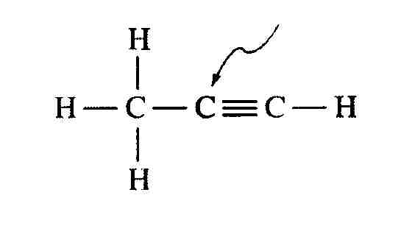

i. indicate the hybridization of the carbon atom indicated by the arrow in the structure above;

ii. indicate the total number of sigma (σ) bonds and the total number of pi (π) bonds in the molecule.

2006 #8
Suppose that a stable element with atomic number 119, symbol Q, has been discovered.
a. Write the ground-state electron configuration for Q, showing only the valence-shell electrons.
b. Would Q be a metal or a nonmetal? Explain in terms of electron configuration.
c. On the basis of periodic trends, would Q have the largest atomic radius in its group or would it have the smallest? Explain in terms of electronic structure.
d. What would be the most likely charge of the Q ion in stable ionic compounds?
e. Write a balanced equation that would represent the reaction of Q with water.
f. Assume that Q reacts to form a carbonate compound.
i. Write the formula for the compound formed between Q and the carbonate ion, CO32 .
ii. Predict whether or not the compound would be soluble in water. Explain your reasoning.
2008 #5

Using principles of atomic and molecular structure and the information in the table below, answer the following questions about atomic fluorine, oxygen, and xenon, as well as some of their compounds.

Atom First Ionization Energy (kJ mole⁻¹)

F 1681.0
O 1313.9
Xe ?

a. Write the equation for the ionization of atomic fluorine that requires 1681.0 kJ mol⁻¹.

b Account for the fact that the first ionization energy of atomic fluorine is greater than that of atomic oxygen. (You must discuss both atoms in your response.)

c. Predict whether the first ionization energy of atomic xenon is greater than, less than, or equal to the first ionization energy of atomic fluorine. Justify your prediction.

d. Xenon can react with oxygen and fluorine to form compounds such as XeO₃ and XeF₄. In the boxes provided, draw the complete Lewis electron dot diagram for each of the molecules represented below.

XeO₃ XeF₄

e. On the basis of the Lewis electron dot diagrams you drew for part d, predict the following

i. the geometric shape of the XeO₃ molecule

ii. the hybridization of the valence orbitals of xenon in XeF₄

f. Predict whether the XeO₃ molecule is polar or nonpolar. Justify your prediction.

2006B #6 GeCl₄ SeCl₄ ICl₄⁻ ICl₄⁺

The species represented above all have the same number of chlorine atoms attached to the central atom.

a. Draw the Lewis structure (electron-dot diagram) of each of the four species. Show all valence electrons in your structures.

b. On the basis of the Lewis structures drawn in part (a), answer the following questions about the particular species indicated.

(i) What is the Cl-Ge-Cl bond angle in GeCl₄?

(ii) Is SeCl₄ polar? Explain.

(iii) What is the hybridization of the I atom in ICl₄⁻?

(iv) What is the geometric shape formed by the atoms in ICl₄⁺?

2006 #7
Answer the following questions about the structures of ions that contain only sulfur and fluorine.
a. The compounds SF₄ and BF₃ react to form an ionic compound according to the following equation.
SF4 + BF3 → SF3BF4
i. Draw a complete Lewis structure for the SF₃⁺ cation in SF₃BF₄.
ii. Identify the type of hybridization exhibited by sulfur in the SF₃⁺ cation.
iii. Identify the geometry of the SF₃⁺ cation that is consistent with the Lewis structure drawn in part (a)(i).
iv. Predict whether the F-S-F bond angle in the SF₃⁺ cation is larger than, equal to, or smaller than 109.5°. Justify your answer.
b. The compounds SF₄ and CsF react to form an ionic compound according to the following equation.
SF₄ + CsF CsSF₅
i. Draw a complete Lewis structure for the SF₅⁻ anion in CsSF₅.
ii. Identify the type of hybridization exhibited by sulfur in the SF₅⁻ anion.
iii. Identify the geometry of the SF₅⁻ anion that is consistent with the Lewis structure drawn in part (b)(i).
iv. Identify the oxidation number of sulfur in the compound CsSF₅.
2008 #6

Answer the following questions by using principles of molecular structure and intermolecular forces.

a. Structures of the pyridine molecule and the benzene molecule are shown below. Pyridine is soluble in water, whereas benzene is not soluble in water. Account of the difference in solubility. You must discuss both of the substances in your answer.

Pyridine Benzene

b. Structures of the dimethyl ether molecule and the ethanol molecule are shown below. The normal boiling point of dimethyl ether is 250 K, whereas the normal boiling point of ethanol is 351 K. Account for the difference in boiling points. You must discuss both of the substances in your answer.

Dimethyl ether Ethanol

c. SO₂ melts at 201 K, whereas SiO₂ melts at 1883 K. Account for the difference in melting points. You must discuss both of the substances in your answer.

d. The normal boiling point of Cl₂(l) (238 K) is higher than the normal boiling point of HCl(l) (188 K). Account for the difference in normal boiling points based on the types of intermolecular forces in the substances. You must discuss both of the substances in your answer.

2009 #6

Answer the following questions related to sulfur and one of its compounds.

a. Consider the two chemical species S and S²⁻.
i. Write the electron configuration (e.g., 1s²2s² …) of each species.
ii. Explain why the radius of the S²⁻ ion is larger than the radius of the S atom.
iii. Which of the two species would be attracted into a magnetic field? Explain.
b. The S²⁻ ion is isoelectronic with the Ar atom. From which species, S²⁻ or Ar, is it easier to remove an electron? Explain.
c. In the H₂S molecule, the H – S – H bond angle is close to 90º. On the basis of this information, which atomic orbitals of the S atom are involved in bonding with the H atoms?
d. Two types of intermolecular forces present in liquid H₂S are London (dispersion) forces and dipole – dipole forces.
i. Compare the strength of the London (dispersion) forces in liquid H₂S to the strength of the London (dispersion) forces in liquid H₂O. Explain.
ii. Compare the strength of the dipole – dipole forces in liquid H₂S to the strength of the dipole – dipole forces in liquid H₂O. Explain.

Multiple Choice Questions

1999 #37
Ionization Energies for element X (kJ mol¯¹)
First | Second | Third | Fourth | Five
580 | 1815 | 2740 | 11600 | 14800
The ionization energies for element X are listed in the table above. On the basis of the data, element X is most likely to be
A) Na
B) Mg
C) Al
D) Si
E) P

2002 #17 In which of the following groups are the three species isoelectronic; i.e., have the same number of electrons?

A) S²⁻, K⁺, Ca²⁺
B) Sc, Ti, V²⁺
C) O²⁻, S²⁻, Cl⁻
D) Mg²⁺, Ca²⁺, Sr²⁺
E) Cs, Ba²⁺, La³⁺

2002 #46 The effective nuclear charge experienced by the outermost electron of Na is different than the effective nuclear charge experienced by the outermost electron of Ne. This difference best accounts for which of the following?

A) Na has a greater density at standard conditions than Ne.
B) Na has a lower first ionization energy than Ne.
C) Na has a higher melting point than Ne.
D) Na has a higher neutron-to-proton ratio than Ne.
E) Na has fewer naturally occurring isotopes than Ne.

2008 #21 Of the following electron configurations of neutral atoms, which represents an atom in an excited state?

A) 1s²2s²2p⁵
B) 1s²2s²2p⁵3s²
C) 1s²2s²2p⁶3s¹
D) 1s²2s²2p⁶3s²3p²
E) 1s²2s²2p⁶3s²3p⁵

1999 #32 Types of hybridization exhibited by the C atoms in propene, CH₃CHCH₂, include which of the following?
I. sp
II. sp²
III. sp³
A) I only
B) III only
C) I and II only
D) II and III only
E) I, II, and III
2008 # 22. Which of the following is a nonpolar molecule that contains polar bonds?

A) F₂
B) CHF₃
C) CO₂
D) HCl
E) NH₃

1999 #75 Which of the following pairs of liquids forms the solution that is most ideal (most closely follows Raoult's law)?
A) C₈H₁₈(l) and H₂O(l)
B) CH₃CH₂CH₂OH(l) and H₂O(l)
C) CH₃CH₂CH₂OH(l) and C₈H₁₈(l)
D) C₆H₁₄(l) and C₈H₁₈(l)
E) H₂SO₄(l) and H₂O(l)

AP Chemistry Concept List – CONCENTRATION UNITS OF SOLUTIONS / COLLIGATIVE PROPERTIES

1. Molarity M = mole of solute/ L of solution

2. molality m = mole of solute / Kg of solvent

3. % by volume = volume of solute / total volume of solution

4. % by weight = weight of solute / total weight of solution

5. mole fraction = x_{a} = mole of a /total moles in solution

Colligative Properties

1. ∆ FP ↓ = (k_{f} ) ( m ) ( i ) freezing point depression

2. ∆ BP ↑ = ( k_{b} ) (m ) ( i ) boiling point elevation

3. ∏ = ( M ) ( R ) ( T ) ( i ) osmotic pressure

4. Vapor Pressure Lowering = VPL = (x _{solvent}) VP _{pure solvent}

The main use of colligative properties is to find the molecular weight of an unknown compound, thus it is related to problems in earlier chapters about empirical or molecular formulas.

i = Van’t Hoff factor

for organic solutes nonelectrolytes i = 1

for electrolytes i = 2,3,4… NaCl i = 2 AlCl₃ i = 4

H₂SO₄ i = 3

Free Response Questions

1998# 2
An unknown compound contains only the three elements C,H, and O. A pure sample of the compound is analyzed and found to be 65.60 percent C and 9.44 percent H by mass.
a. Determine the empirical formula of the compound.
b. A solution of 1.570 grams of the compound in 16.08 grams of camphor is observed to freeze at a temperature 15.2 Celsius below the normal freezing point of pure camphor. Determine the molar mass and apparent molecular formula of the compound. (The molal freezing-point depression constant, k_{f}, for camphor is 40.0 kg-K-mol⁻¹.)
c. When 1.570 grams of the compound is vaporized at 300 °C and 1.00 atmosphere, the gas occupies a volume of 577 milliliters. What is the molar mass of the compound based on this result?
d. Briefly describe what occurs in solution that accounts for the difference between the results obtained in parts (b) and (c).
1999 # 7
Answer the following questions, which refer to the 100 mL samples of aqueous solutions at 25°C in the stoppered flasks shown below.

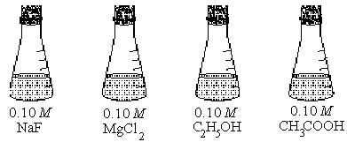

a. Which solution has the lowest electrical conductivity? Explain.

b. Which solution has the lowest freezing point? Explain.

c. Above which solution is the pressure of water vapor greatest? Explain.

d. Which solution has the highest pH? Explain.

2001 # 5

Answer the questions below that related to the five aqueous solutions at 25 ºC shown below.

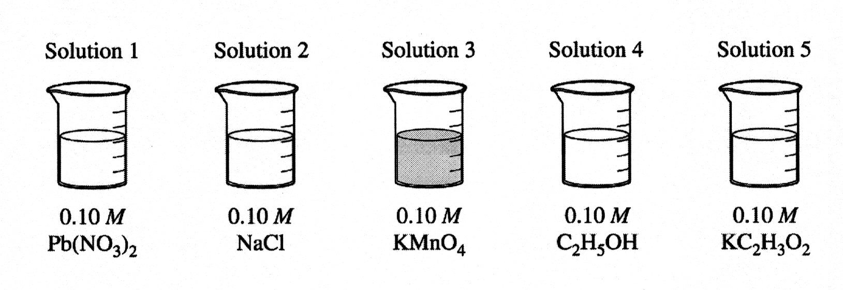
a. Which solution has the highest boiling point? Explain.

b. Which solution has the highest pH? Explain.

c. Identify a pair of the solutions that would produce a precipitate when mixed together. Write the formula of the precipitate.

d. Which solution could be used to oxidize the Cl⁻(aq) ion? Identify the product of the oxidation.

e. Which solution would be the least effective conductor of electricity? Explain.

Multiple Choice Questions

2002 #35 A solution is made by dissolving a nonvolatile solute in pure solvent. Compared to the pure solvent, the solution

A) has a higher normal boiling point.
B) has a higher vapor pressure.
C) has the same vapor pressure.
D) has a higher freezing point.
E) is more nearly ideal.

2008 #53 A sample of 10.0 mol of butyric acid, HC₄H₇O₂, a weak acid, is dissolved in 1000. g of water to make a 10.0 molal solution. Which of the following would be the best methods to determine the molarity of the solution? (In each case, assume that no additional information is available)

A) Titration of the solution with standard acid
B) Measurement of the pH with a pH meter
C) Determination of the freezing point of the solution
D) Measurement of the total volume of the solution
E) Measurement of the electrical conductivity of the solution

2008 #54. The nonvolatile compound ethylene glycol, C₂H₆O₂, forms nearly ideal solutions with water. What is the vapor pressure of a solution made from 1.00 mol of C₂H₆O₂ and 9.00 moles of H₂O if the vapor pressure of pure water at the same temperature is 25.0 mm Hg?

A) 2.50 mm Hg
B) 7.50 mm Hg
C) 12.5 mm Hg
D) 22.5 mm Hg
E) 27.5 mm Hg

2008 #68 The pH of a solution prepared by the addition of 10. mL of 0.002 M KOH(aq) to 10. mL of distilled water is closest to

A) 12
B) 11
C) 10
D) 4
E) 3

AP Chemistry – LABORATORY QUESTIONS

1. Vocabulary words

ppt (precipitate)

Free Response Questions

2008 B #5

The identity of an unknown solid is to be determined. The compound is one of the seven salts in the following table.

Al(NO₃)₃·9H₂O BaCl₂·2H₂O CaCO₃ CuSO₄·5H₂O NaCl

BaSO₄ Ni(NO₃)₂·6H₂O

Use the results of the following observations or laboratory tests to explain how each compound in the table may be eliminated or confirmed. The tests are done in sequence from a) through e).

a. The unknown compound is white. In the table below, cross out the two compounds that can be eliminated using this observation. Be sure to cross out the same two compounds in the tables in parts b, c, and d.

Al(NO₃)₃·9H₂O BaCl₂·2H₂O CaCO₃ CuSO₄·5H₂O NaCl

BaSO₄ Ni(NO₃)₂·6H₂O

b. When the unknown compound is added to water, it dissolves readily. In the table below, cross out the two compounds that can be eliminated using this test. Be sure to cross out the same two compounds in the tables in parts c and d.

Al(NO₃)₃·9H₂O BaCl₂·2H₂O CaCO₃ CuSO₄·5H₂O NaCl

BaSO₄ Ni(NO₃)₂·6H₂O

c. When AgNO₃(aq) is added to an aqueous solution of the unknown compound, a white precipitate forms. In the table below, cross out each compound that can be eliminated using this test. Be sure to cross out the same compound(s) in the table in part d.

Al(NO₃)₃·9H₂O BaCl₂·2H₂O CaCO₃ CuSO₄·5H₂O NaCl

BaSO₄ Ni(NO₃)₂·6H₂O

d. When the unknown compound is carefully heated, it loses mass. In the table below, cross out each compound that can be eliminated using this test.

Al(NO₃)₃·9H₂O BaCl₂·2H₂O CaCO₃ CuSO₄·5H₂O NaCl

BaSO₄ Ni(NO₃)₂·6H₂O

e. Describe a test that can be used to confirm the identity of the unknown compound identified in part d. Limit your confirmation test to a reaction between an aqueous solution of the unknown compound and an aqueous solution of one of the other soluble salts listed in the tables. Describe the expected results of the test; include the formula(s) of any product(s).

2008 B#3

A 0.150 g sample of solid lead (II) nitrate is added to 125 mL of 0.100 M sodium iodide solution. Assume no change in volume of the solution. The chemical reaction that takes place is represented by the following equation.

Pb(NO₃)₂(s) + 2 NaI(aq) PbI₂(s) + 2 NaNO₃(aq)

a. List an appropriate observation that provides evidence of a chemical reaction between the two compounds.

b. Calculate the number of moles of each reactant.

c. Identify the limiting reactant. Show calculations to support your identification.

d. Calculate the molar concentration of NO₃⁻(aq) in the mixture after the reaction is complete.

e. Circle the diagram below that best represents the results after the mixture reacts as completely as possible. Explain the reasoning used in making your choice.

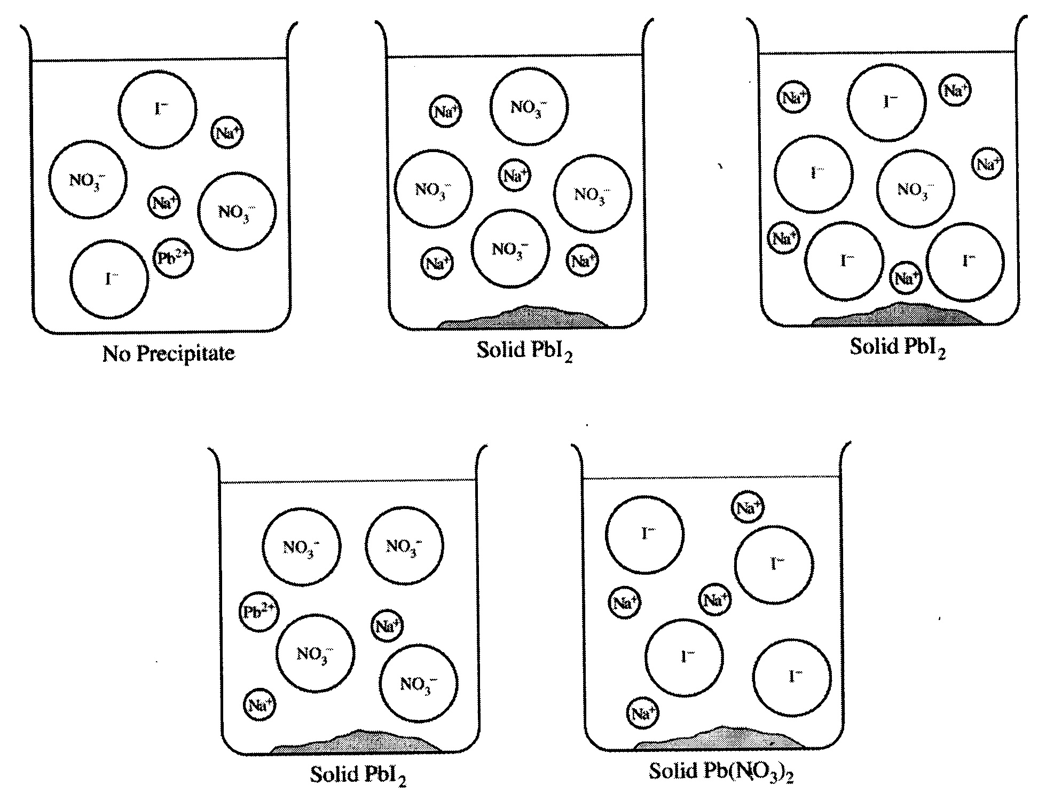

2007 #5

5 Fe²⁺(aq) + MnO₄⁻(aq) + 8H⁺(aq) 5Fe³⁺(aq) + Mn²⁺(aq) + 4H₂O(l)

The mass percent of iron in a soluble iron(II) compound is measured using a titration based on the balanced equation above.

a. What is the oxidation number of manganese in the permanganate ion, MnO₄⁻(aq)?

b. Identify the reducing agent in the reaction represented above.

The mass of a sample of the iron(II) compound is carefully measured before the sample is dissolved in distilled water. The resulting solution is acidified with H₂SO₄(aq). The solution is then titrated with MnO₄⁻(aq) until the end point is reached.

c. Describe the color change that occurs in the flask when the end point of the titration has been reached. Explain why the color of the solution changes at the end point.

d. Let the variables g, M, and V be defined as follows:

g = the mass, in grams, of the sample of the iron(II) compound

M= the molarity of the MnO₄⁻(aq) used as the titrant

V= the volume, in liters, of MnO₄⁻(aq) added to reach the end point

In terms of these variables, the number of moles of MnO₄⁻(aq) added to reach the end point of the titration is expressed as M × V. Using the variables defined above, the molar mass of iron (55.85 g mol⁻¹), and the coefficients in the balanced chemical equation, write the expression for each of the following quantities.

i. The number of moles of iron in the sample

ii. The mass of iron in the sample, in grams

iii. The mass percent of iron in the compound

e. What effect will adding too much titrant have on the experimentally determined value of the mass percent of iron in the compound? Justify your answer.

2007 B #5

Answer the following questions about laboratory situations involving acids, bases, and buffer solutions.

a. Lactic acid, HC₃H₅O₃, reacts with water to produce an acidic solution. Shown below are the complete Lewis structures of the reactants.

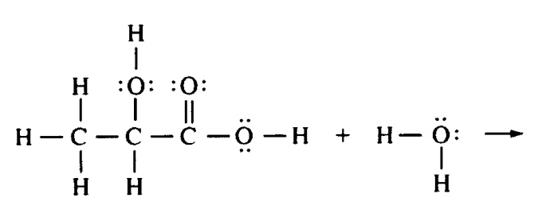
In the space provided above, complete the equation by drawing the complete Lewis structures of the reaction products.

b. Choosing from the chemicals and equipment listed below, describe how to prepare 100.00 mL of a 1.00 M aqueous solution of NH₄Cl (molar mass 53.5 g mol⁻¹). Include specific amounts and equipment where appropriate.

NH₄Cl(s) 50 mL buret 100 mL graduated cylinder 100 mL pipet
Distilled water 100 mL beaker 100 mL volumetric flask Balance

c. Two buffer solutions, each containing acetic acid and sodium acetate, are prepared. A student adds 0.10 mol of HCl to 1.00 L of each of these buffer solutions and to 1.0 L of distilled water. The table below shows the pH measurements made before and after the 0.10 mol of HCl is added.

pH before pH after
HCl added HCl added

Distilled water 7.0 1.0
Buffer 1 4.7 2.7
Buffer 2 4.7 4.3

i. Write the balanced net ionic equation for the reaction that takes place when the HCl is added to buffer 1 or buffer 2.

ii. Explain why the pH of buffer 1 is different from the pH of buffer 2 after 0.10 mol of HCl is added.

iii. Explain why the pH of buffer 1 is the same as the pH of buffer 2 before 0.10 mol of HCl is added.

2000 # 5

The molar mass of an unknown solid, which is nonvolatile and a nonelectrolyte, is to be determined by the freezing-point depression method. The pure solvent used in the experiment freezes at 10 ºC and has a known molal freezing-point depression constant, k_{f}. Assume that the following materials are also available.

Test tubes stirrer pipet thermometer balance
Beaker stopwatch graph paper hot-water bath ice

a. Using the two sets of axes provided below, sketch cooling curves for (i) the pure solvent and for (ii) the solution as each is cooled for 20 ºC to 0.0 ºC.
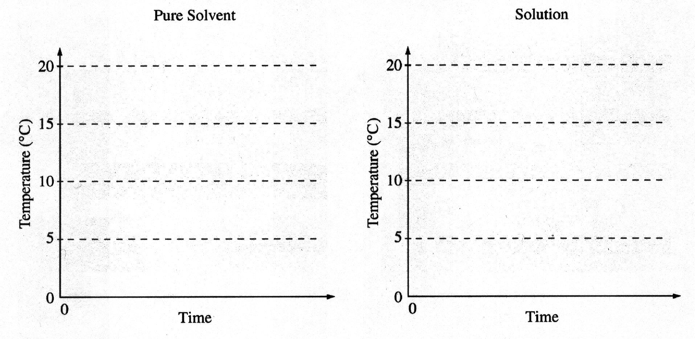

b. Information from these graphs may be used to determine the molar mass of the unknown solid.

i) Describe the measurements that must be made to determine the molar mass of the unknown solid by this method.

ii) Show the setup(s) for the calculation(s) that must be performed to determine the molar mass of the unknown solid from the experimental data.

iii) Explain how the difference(s) between the two graphs in part a) can be used to obtain information needed to calculate the molar mass of the unknown solid.

c. Suppose that during the experiment a significant but unknown amount of solvent evaporates from the test tube. What effect would this have on the calculated value of the molar mass of the solid (i.e., too large, too small, or no effect)? Justify your answer.

d. Show the setup for the calculation of the percentage error in a student’s result if the student obtains a value of 126 g mol⁻¹ for the molar mass of the solid when the actual value is 120. g mol⁻¹.

2005 # 5
Answer the following questions that relate to laboratory observations and procedures.
a. An unknown gas is one of three possible gases: nitrogen, hydrogen, or oxygen. For each of the three possibilities, describe the result expected when the gas is tested using a glowing splint (a wooden stick with one end that has been ignited and extinguished, but still contains hot, glowing, partially burned wood).
b. The following three mixtures have been prepared: CaO plus water, SiO₂ plus water, and CO₂ plus water. For each mixture, predict whether the pH is less than 7, equal to 7, or greater than 7. Justify your answers.
c. Each of three beakers contains a 0.1 M solution of one of the following solutes: potassium chloride, silver nitrate, or sodium sulfide. The three beakers are labeled randomly as solution 1, solution 2, and solution 3. Shown below is a partially completed table of observations made of the results of combining small amounts of different pairs of the solutions.
 | Solution 1 | Solution 2 | Solution 3
Solution 1 |  | black precipitate
Solution 2 |  |  | no reaction
Solution 3
i) Write the chemical formula of the black precipitate.
ii) Describe the expected results of mixing solution 1 with solution 3.
iii) Identify each of the solutions 1, 2, and 3.

2005B #5

2 Al(s) + 2 KOH(aq) + 4 H₂SO₄(aq) + 22 H₂O(l) 2 KAl(SO₄)₂·12 H₂O + 3 H₂(g)

In an experiment, a student synthesizes alum, KAl(SO₄)₂·12H₂O(s), by reacting aluminum metal with potassium hydroxide and sulfuric acid, as represented in the balanced equation above.

a. In order to synthesize alum, the student must prepare a 5.0 M solution of sulfuric acid. Describe the procedure for preparing 50.0 mL of 5.0 M H₂SO₄ using any of the chemicals and equipment listed below. Indicate specific amounts and equipment where appropriate.

10.0 M H₂SO₄ 50.0 mL volumetric flask
Distilled water 50.0 mL buret
100 mL graduated cylinder 25.0 mL pipet
100 mL beaker 50 mL beaker

b. Calculate the minimum volume of 5.0 M H₂SO₄ that the student must use to react completely with 2.7 g of aluminum metal.

c. As the reaction solution cools, alum crystals precipitate. The student filters the mixture and dries the crystals, then measures their mass.

i) If the student weighs the crystals before they are completely dry, would the calculated percent yield be greater than, less than, or equal to the actual percent yield? Explain.

ii) Cooling the reaction solution in an ice bath improves the percent yield obtained. Explain.

d. The student heats crystals of pure alum, KAl(SO₄)₂·12 H₂O(s), in an open crucible to a constant mass. The mass of the sample after heating is less than the mass before heating. Explain.

Multiple Choice Questions

1999 #27 Appropriate uses of a visible-light spectrophotometer include which of the following?
I. Determining the concentration of a solution of Cu(NO₃)₂
II. Measuring the conductivity of a solution of KMnO₄
III. Determining which ions are present in a solution that may contain Na⁺, Mg²⁺, Al³⁺
A) I only
B) II only
C) III only
D) I and II only
E) I and III only

2002 #50 Which of the following represents acceptable laboratory practice?

A) Placing a hot object on a balance pan.
B) Using distilled water for the final rinse of a buret before filling it with standardized solution.
C) Adding a weighed quantity of solid acid to a titration flask wet with distilled water.
D) Using 10 mL of standard strength phenolphthalein indicator solution for titration of 25 mL of acid solution.
E) Diluting a solution in a volumetric flask to its final concentration with hot water.

2008 #47 When diluting concentrated H₂SO₄, one should slowly add acid to a beaker of water rather than add water to a beaker of acid. The reason for this precaution is to ensure that

A) there is complete ionization of the H₂SO₄
B) there is sufficient volume of water to absorb the heat released
C) the water does not sink beneath the acid and remain unmixed
D) the acid does not react with impurities in the dry beaker
E) any SO₂ released quickly redissolves in the water

2008 #65
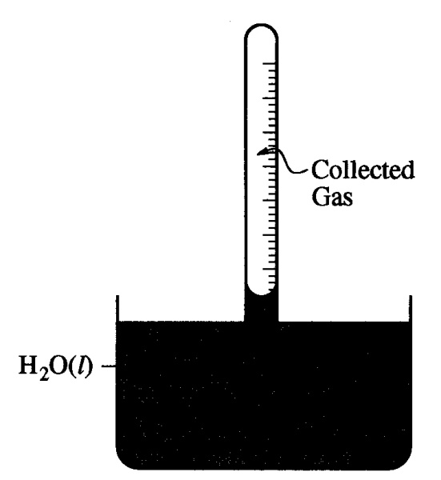
In a laboratory experiment, H₂(g) is collected over water in a gas-collection tube as shown in the diagram above. The temperature of the water is 21 ºC and the atmospheric pressure in the laboratory is determined to be 772 torr. Before measuring the volume of the gas collected in the tube, what step, if any, must be taken to make it possible to determine the total gas pressure inside the tube?

A) tilt the tube to the side enough to let some air in to break the partial vacuum in the tube
B) lift the tube upward until it is just barely immersed in the water
C) move the tube downward until the water level is the same inside and outside the tube
D) Adjust the temperature of the water to 25 ºC
E) No further steps need to be taken as long as the temperature of the water is known

2008 #62 Which of the following pieces of laboratory glassware should be used to most accurately measure out a 25.00 mL sample of a solution?

A) 5 mL pipet
B) 25 mL pipet
C) 25 mL beaker
D) 25 mL Erlenmeyer flask
E) 50 mL graduated cylinder

AP Chemistry – NUCLEAR QUESTIONS

1. See also the separate nuclear study packet on this CD.

Free Response Questions

2003B # 8

The decay of the radioisotope I-131 was studied in a laboratory. I-131 is known to decay by beta (₋₁⁰e) emission.

a. Write a balanced nuclear equation for the decay of I-131.

b. What is the source of the beta particle emitted from the nucleus?

The radioactivity of a sample of I-131 was measured. The data collected are plotted on the graph below.

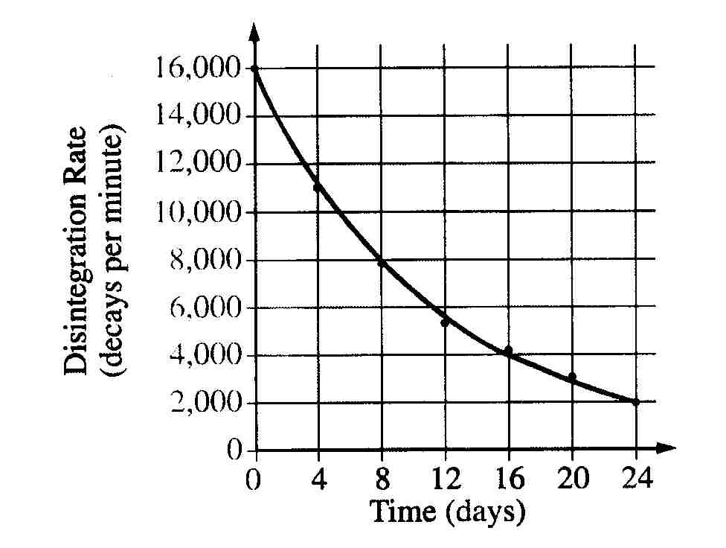

c. Determine the half-life, t_{1/2}, of I-131 using the graph above.

d. The data can be used to show that the decay of I-131 is a first-order reaction, as indicated on the graph below.

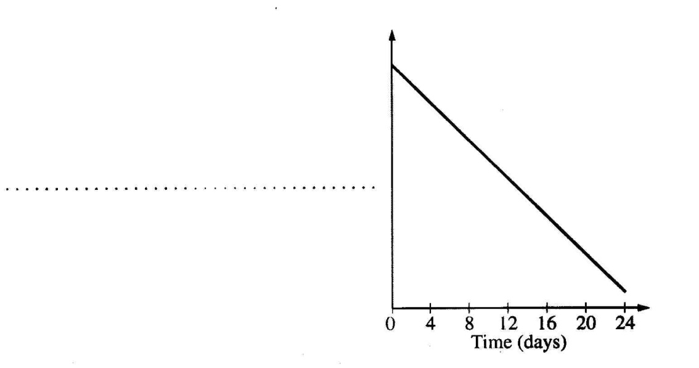

i. Label the vertical axis of the graph above.

ii. What are the units of the rate constant, k, for the decay reaction?

iii. Explain how the half-life of I-131 can be calculated using the slope of the line plotted on the graph.

e. Compare the value of the half-life of I-131 at 25 ºC to its value at 50 ºC

Multiple Choice Questions

2002 #23 ${}_{92}^{235}{\text{U}}+{}_{0}^{1}n\underset{→}{}{}_{55}^{141}{\text{Cs}+3{}_{0}^{1}n+\text{X}}$

Neutron bombardment of uranium can induce the reaction represented above. Nuclide X is which of the following?

A) ${}_{35}^{92}{\text{Br}}$
B) ${}_{35}^{94}{\text{Br}}$
C) ${}_{37}^{91}{\text{Rb}}$
D) ${}_{37}^{92}{\text{Rb}}$
E) ${}_{37}^{94}{\text{Rb}}$

2008 #24 Which of the following shows the correct number of protons, neutrons, and electrons in a neutral cesium-134 atom?
Protons Neutrons Electrons
A) 55 55 55
B) 55 79 55
C) 55 79 79
D) 79 55 79
E) ` 134 55 134

2008 #27 Which of the following is a correctly balanced nuclear reaction?
A) ${}_{92}^{238}{\text{U}}\underset{→}{}{}_{90}^{232}{\text{Th}}+{}_{2}^{4}{\text{He}}$
B) ${}_{98}^{249}{\text{Cf}+{}_{7}^{15}{\text{N}}}\underset{→}{}{}_{105}^{260}{\text{Db}}+3{}_{0}^{1}n$
C) ${}_{1}^{2}{\text{H}+{}_{1}^{3}{\text{H}}}\underset{→}{}{}_{2}^{4}{\text{He}}+2{}_{0}^{1}n$
D) ${}_{92}^{238}{\text{U}+{}_{0}^{1}n}\underset{→}{}{}_{92}^{239}{\text{U}}$
E) ${}_{19}^{40}{\text{K}}\underset{→}{}{}_{20}^{40}{\text{Ca}}+{}_{+1}^{0}β$

AP CHEMISTRY – MULTI-CONCEPT QUESTIONS

2008 #3 – electrochemistry thermodynamics kinetics

Answer the following questions related to chemical reactions involving nitrogen monoxide, NO(g).

The reaction between solid copper and nitric acid to form copper (II) ion, nitrogen monoxide gas, and water is represented by the following equation.

3 Cu(s) + 2 NO₃⁻(aq) + 8 H⁺(aq) 3 Cu²⁺(aq) + 2 NO(g) + 4 H₂O(l) Eº = +0.62 V

a. Using the information above and in the table below, calculate the standard reduction potential, Eº, for the reduction of NO₃⁻ in acidic solution.

Half-reaction Standard Reduction Potential, Eº
Cu²⁺(aq) + 2e⁻ Cu(s) +0.34 V
NO₃⁻(aq) + 4H⁺(aq) + 3e⁻ NO(g) + 2H₂O(l) ?

b. Calculate the value of the standard free energy change, ΔGº, for the overall reaction between solid copper and nitric acid.

c. Predict whether the value of the standard entropy change, ΔSº, for the overall reaction is greater than 0, less than 0, or equal to 0. Justify your prediction.

Nitrogen monoxide gas, a product of the reaction above, can react with oxygen to produce nitrogen dioxide gas, as represented below.

2 NO(g) + O₂(g) 2 NO₂(g)

A rate study of the reaction yielded the data recorded in the table below.

Expt. Initial Concentration Initial Concentration Initial Rate of
of NO (mol L⁻¹) of O₂ (mol L⁻¹) Formation of NO₂
(mol L⁻¹ s⁻¹)

1 0.0200 0.0300 8.52 × 10⁻²
2 0.0200 0.0900 2.56 × 10⁻¹
3 0.0600 0.0300 7.67 × 10⁻¹

d. Determine the order of the reaction with respect to each of the following reactants. Give details of your reasoning, clearly explaining or showing how you arrived at your answers.

i. NO

ii. O₂

e. Write the expression for the rate law for the reaction as determined from the experimental data.

f. Determine the value of the rate constant for the reaction, clearly indicating the units.

2007B #1 - equilibrium thermodynamics gas laws

A sample of solid U₃O₈ is placed in a rigid 1.500 L flask. Chlorine gas, Cl₂(g), is added, and the flask is heated to 862ºC. The equation for the reaction that takes place and the equilibrium-constant expression for the reaction are given below.

U₃O₈(s) + 3Cl₂(g) 3UO₂Cl₂(g) + O₂(g)

When the system is at equilibrium, the partial pressure of Cl₂(g) is 1.007 atm and the partial pressure of UO₂Cl₂(g) is 9.734 × 10⁻⁴ atm.

a. Calculate the partial pressure of O₂(g) at equilibrium at 862ºC.

b. Calculate the value of the equilibrium constant, K_{p}, for the system at 862ºC.

c. Calculate the Gibbs free-energy change, ΔGº, for the reaction at 862ºC.

d. State whether the entropy change, ΔSº, for the reaction at 862ºC is positive, negative, or zero. Justify your answer.

e. State whether the enthalpy change, ΔHº, for the reaction at 862ºC is positive, negative, or zero. Justify your answer.

f. After a certain period of time, 1.000 mol of O₂(g) is added to the mixture in the flask. Does the mass of U₃O₈(s) in the flask increase, decrease, or remain the same? Justify your answer.

2007B #3 – stoichiometry electrochemistry gas laws

2 H₂(g) + O₂(g) 2 H₂O(l)

In a hydrogen-oxygen fuel cell, energy is produced by the overall reaction represented above.

a. When the fuel cell operates at 25ºC and 1.00 atm for 78.0 minutes, 0.0746 mol of O₂(g) is consumed. Calculate the volume of H₂(g) consumed during the same time period. Express your answer in liters measured at 25ºC and 1.00 atm.

b. Given that the fuel cell reaction takes place in an acidic medium,

i. write the two half reactions that occur as the cell operates,

ii. identify the half reaction that takes place at the cathode, and

iii. determine the value of the standard potential, Eº, of the cell.

c. Calculate the charge, in coulombs, that passes through the cell during the 78.0 minutes of operation as described in part a.

2007 #3 – electrochemistry thermodynamics

An external direct-current power supply is connected to two platinum electrodes immersed in a beaker containing 1.0 M CuSO₄(aq) at 25ºC, as shown in the diagram above. As the cell operates, copper metal is deposited onto one electrode and O₂(g) is produced at the other electrode. The two reduction half-reactions for the overall reaction that occurs in the cell are shown in the table below.

half-reaction Eº(V)
O₂(g) + 4 H⁺(aq) + 4 e⁻ 2H₂O(l) +1.23
Cu²⁺(aq) + 2e⁻ Cu(s) +0.34

a. On the diagram, indicate the direction of electron flow in the wire.

b. Write a balanced net ionic equation for the electrolysis reaction that occurs in the cell.

c. Predict the algebraic sign of ΔGº for the reaction. Justify your prediction.

d. Calculate the value of ΔGº for the reaction.

An electric current of 1.50 amps passes through the cell for 40.0 minutes.

e. Calculate the mass, in grams, of the Cu(s) that is deposited on the electrode.

f. Calculate the dry volume, in liters measured at 25ºC and 1.16 atm, of the O₂(g) that is produced.

2006 #6 – IMF’s thermodynamics kinetics
Answer each of the following in terms of principles of molecular behavior and chemical concepts.
a. The structures for glucose, C₆H₁₂O₆, and cyclohexane, C₆H₁₄, are shown below.
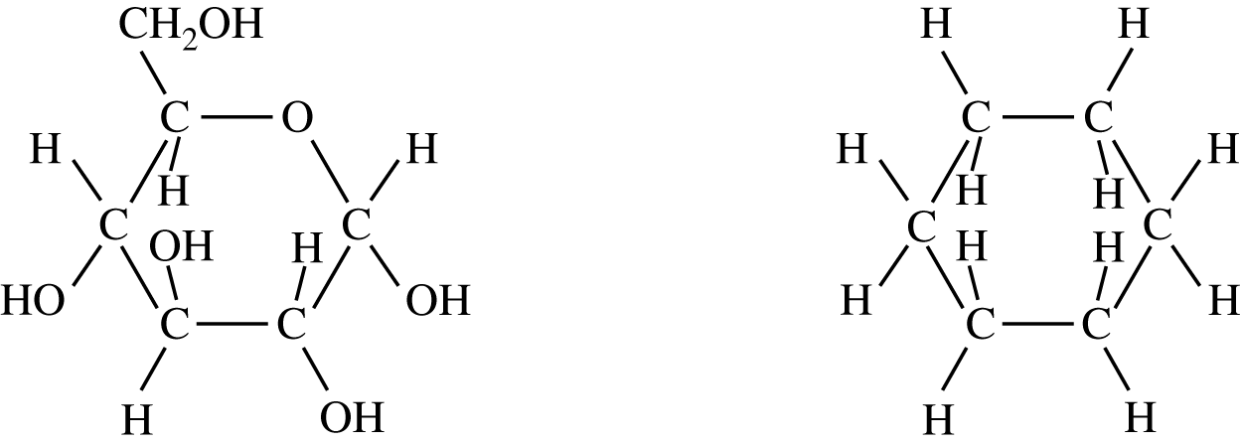
Identify the type(s) of intermolecular attractive forces in
(i) pure glucose
(ii) pure cyclohexane
b. Glucose is soluble in water but cyclohexane is not soluble in water. Explain.
c. Consider the two processes represented below.
Process 1: H2O(l) → H2O(g) ΔH° = +44.0 kJ mol−1
Process 2: H2O(l) → H2(g) + ΔH° = +286kJ mol−1
i. For each of the two processes, identify the type(s) of intermolecular or intramolecular attractive forces that must be overcome for the process to occur.
ii. Indicate whether you agree or disagree with the statement in the box below. Support your answer with a short explanation.
When water boils, H2O molecules break apart to
form hydrogen molecules and oxygen molecules.
d. Consider the four reaction-energy profile diagrams shown below.
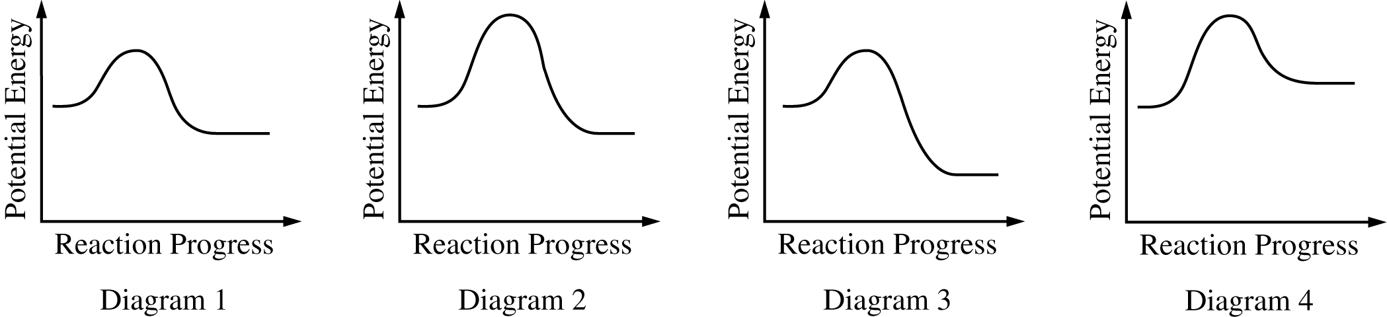

i. Identify the two diagrams that could represent a catalyzed and an uncatalyzed reaction pathway for the same reaction. Indicate which of the two diagrams represents the catalyzed reaction pathway for the reaction.
ii. Indicate whether you agree or disagree with the statement in the box below. Support your answer with a short explanation.
Adding a catalyst to a reaction mixture adds energy that causes the reaction to proceed more quickly.

2011B #6

6. Use principles of molecular structure, intermolecular forces, and kinetic molecular theory to answer the following questions.

a.) A complete Lewis electron dot diagram of a molecule of ethyl methanoate is given below.
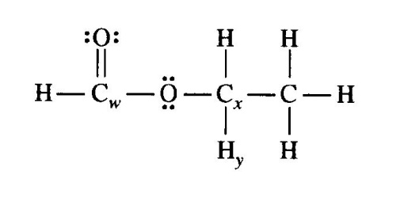
i.) Identify the hybridization of the valence electrons of the carbon atoms labeled C_{w}.

ii.) Estimate the numerical value of the H_{y} – C_{x} – O bond angle in an ethyl methanoate molecule. Explain the basis of your estimate.

b.) Ethyl methanoate, CH₃CH₂OCHO, is synthesized in the laboratory from ethanol, C₂H₅OH, and methanoic acid, HCOOH, as represented by the following equation.

C₂H₅OH(l) + HCOOH(l) CH₃CH₂OCHO(l) + H₂O(l)

i.) In the box below, draw the complete Lewis electron dot diagram of a methanoic acid molecule.

ii.) In the box below, draw the complete Lewis electron dot diagrams of a methanoic acid molecule and a water molecule in an orientation that allows a hydrogen bond to form between them.

Hydrogen Bonding between Methanoic Acid and Water

c.) A small amount of liquid ethyl methanoate (boiling point 54 ºC) was placed in a rigid closed 2.0 L container containing argon gas at an initial pressure of 1.00 atm and a temperature of 20 ºC. The pressure in the container was monitored for 70. seconds after the ethyl methanoate was added, and the data in the graph below were obtained. It was observed that some liquid ethyl methanoate remained in the flask after 70.0 seconds. (Assume that the volume of the remaining liquid is negligible compared to the total volume of the container.)
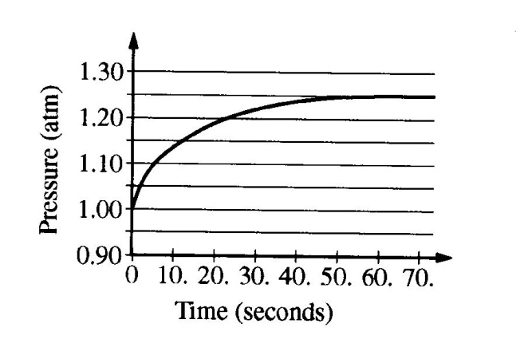
i.) Explain why the pressure in the flask increased during the first 60. seconds.

ii.) Explain, in terms of processes occurring at the molecular level, why the pressure in the flask remained constant after 60. seconds.

iii.) What is the value of the partial pressure of ethyl methanoate vapor in the container at 60. seconds?

iv.) After 80. seconds, additional liquid ethyl methanoate is added to the container at 20 ºC. Does the partial pressure of the ethyl methanoate vapor in the container increase, decrease, or stay the same? Explain. (Assume that the volume of the additional liquid ethyl methanoate in the container is negligible compared to the total volume of the container.)

